**Measurement of Harmonics, Direct Current (DC) Injection & Flicker as per (Grid India)/RLDC Guidelines**



**PSS @ POI point**

**Bay No – 609**

**Customer: M/s Tata Power Renewable Energy Ltd**

**Block-27, 50 MW Solar Power Project**

**2050MW Pavagada Solar Park**

Village-Tirumani-Pavagada Taluk Tumkur- Dist. 561202

Reference: IPR/171/2024-25 dt 27th May 2025 Rev – 0



*Consultant:*

***IPR Technologies Pvt Ltd***

[***info@iprtechnologies.com***](mailto:info@iprtechnologies.com) ***/*** [***madtechsol@gmail.com***](mailto:madtechsol@gmail.com)

***Ph : 9538044488/9900066531***

***www. iprtechnologies.com***

**Power Quality Test Report**

|  |  |  |  |  |  |
| --- | --- | --- | --- | --- | --- |
| Test Report Number: | | | | IPR/009/2024-25 dt 27th May 2025 | |
| 1 | Name and address of Customer | | | **M/s Tata Power Renewable Energy Ltd**  Block-27, 50 MW Solar Power Project,  2050MW Pavagada Solar Park, Tyreman Village, Pavagada taluk, Tumkur Dist. 561202 | |
| 2 | Reference:  Service request form number  Date of receipt of EUT | | | - | |
| 3 | Location of testing: | | | **66/11 KV, Tata Pooling Substation**  **Tirumani**  **Feeder No: 66kV Bay No: 609** | |
| 4 | Testing Detail: Date of issue:  Date of connection, Time:  Date of disconnection, Time  Date Considered for Report: | | | 05/05/2025  06/05/2025 12:30 PM  13/05/2025 07:30 PM  06/05/2025 06:30 PM to 13/05/2025 06:30 PM | |
| 5 | Duration of testing:  (For solar generators separate reports to be submitted for Day and Night hours) | | | 7 Days | |
| 6 | Description of Measurement: | | | Power quality measurement as per POSOCO’s  Detailed Guidelines | |
| Measurement Point (PCC): | | | **66/11 KV, Tata Pooling Substation**  **Feeder No: 66kV Bay No: 609** | |
| 7 | Environmental conditions of measurements | | |  | |
| Temperature: | | | 29° C | |
| Relative humidity: | | | 27% | |
| 8 | Witnessed by: | | | Mr. Abdul | |
| 9 | Description of Power Quality Analyzer used for testing: | | | | |
| Power Quality Analyzer | | Calibrated on | Calibration Due on | | Parameters |
| Power Quality & Energy Analyzer Make: Elspec Model: Pure BB  Sr No: 00-60-35-38-0E-32 | | 03/03/2025 | 02/03/2026 | | Voltage Harmonics  Current Harmonics  Flicker  DC Current Injection &  Other Parameters |

In addition to above the RE Generator may provide the technical data like full load current, installed capacity and available capacity during measurement.

|  |  |
| --- | --- |
| 10 | Measurement Procedure:   * Voltage R Y B and N Leads to be connected to the PT Secondary. * CT Secondary leads to be passed through the inbuilt CTs in the instrument as per the current direction. * The CT PT ratio to be entered before the measurement is started. After the measurement completed all the parameters to be selected to be processed in the software and report is generated |

**Solar Farm PSS**

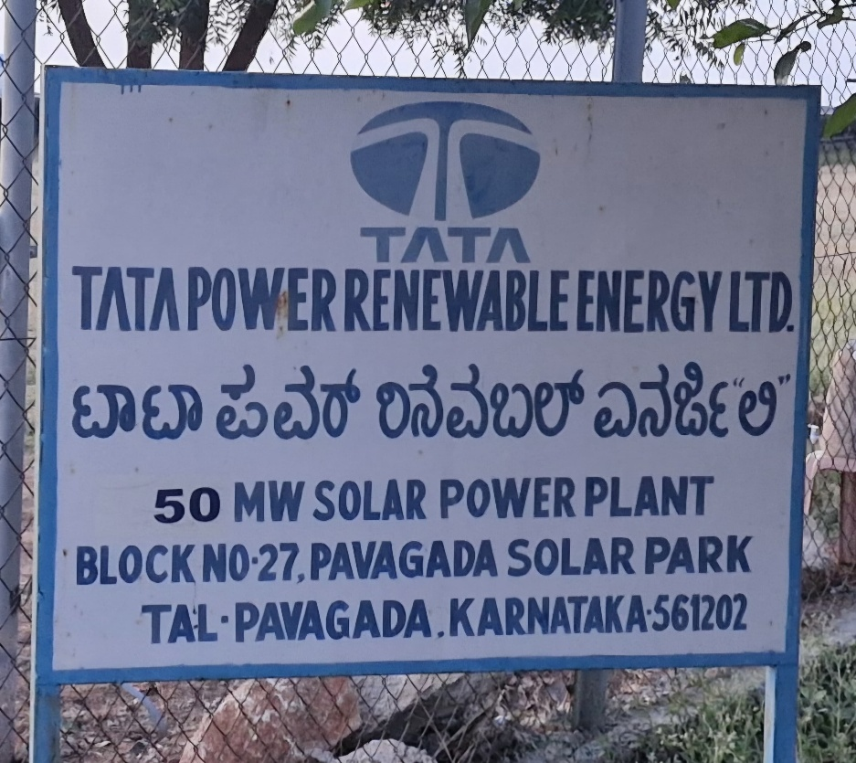

**Tata Solar Plant**

M/s **IPR Technologies** is a customer-focused, innovative and independent, technical, quality services organization, dedicated to providing future- proof solutions through technological excellence for the success of its customers with the highest level of integrity for more than a decade of service.

IPR Technologies is an ISO 9001:2015 certified company, promoted by a set of technocrats with several decades of rich and varied experience in the field of Engineering and Grid compliance in India and other countries.

We are the India’s leading Grid expert team and a recognized advisor for the renewable industry. We deliver world-renowned testing, Grid compliance and technical advisory services to the Power industries including Renewables. We have evolved from success in wind farm electrical power collection network (PCN) and Grid compliance studies, developing innovative software for Electrical industries. Head office in Bangalore, India, we are a leader and one of the most recognized organization representing commitment and trust.

In specific Optimum Electrical Design of Wind & Solar Farm, Evacuation Studies for Wind/Solar/Thermal generation, Inter regional off taker / LTA study, Substation Design, Technical Consultancy Services, Solar AC / DC design, Reactive Power Studies, all kinds of studies pertaining to POSOCO / RLDC submission of ISTS projects. Simulation Software Development & Advisory for Energy Trading Solutions. Complete Technical Due-diligences for Wind / Solar project acquisition. Simulation & Energy Audit of existing Sites.

IPR had carried out the studies related to ISTS/CTU and STU connectivity. Few Studies are mandatory and to be submitted to RLDC during execution of the project & final revision after completion of the project. As we are supporting many other IPPs in the industry including various OEM and leading IPPs and also leading renewable energy consultants.

1. Reactive Power Studies for Wind Farm/Solar Farm
2. LVRT study
3. HVRT Study
4. Detailed model & equivalent model of the wind farm / Solar farm
5. PSCAD modelling –Generally will be developed by Turbine manufacture. - We can review third party developed model. Both Individual turbine & equivalent model.

All the above required studies have been carried out by for various clients and the same is well accepted by POSOCO, RLDC and other agencies.

Other than RLDC submission we are supporting in the following areas for project cost optimization,

1. We would design 33 KV Wind farm electrical network (PCN) with most optimized LOSS & Electrical investment, also optimized Sub-station location.
2. Energy Loss assessment of the wind farm (based on 10 Min Wind mast data).
3. Mobile & WEB integrated Survey application for Wind farm execution.

We have developed World's First Power Simulation Software in Mobile and supplied to Utilities. This in-house development of Distribution Simulation Software supplied to distribution utility BESCOM, KPTCL & private users. We have developed Web & Mobile innovative application and supplied to Transmission Utility - KPTCL, Karnataka. IPR have developed WEB Enabled Load flow Study integrated with Mobile for Optimum Wind farm Power Collection design.

# Measuring Instrument

The measurements were carried out by using Elspec make Power Quality Analyzer : Pure BlackBox

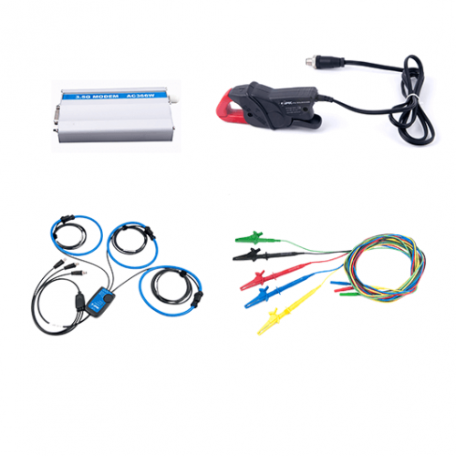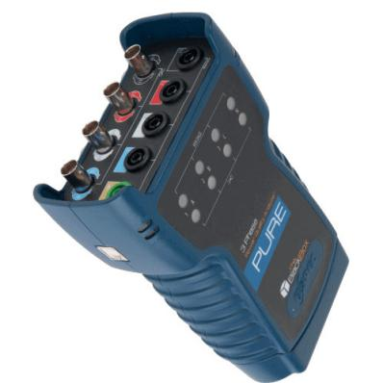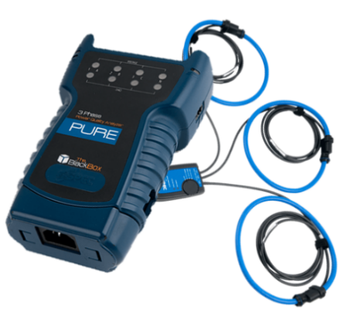

Figure 1: Pure Black Box PQA

The Pure BlackBox, an advanced handheld power quality analyzer equipped with PQZIP Technology, is an easy to use plug and play device that continuously records all power quality parameters without thresholds settings or recording configuration. The device is available in 2 versions: Single Phase, 3-Phase.

**Continuous Waveform Recordings:**

The Pure BlackBox continuously records voltage and current waveform sampled at a rate of 256 Sample/Cycle at 50/60Hz. Which provides information at a very high resolution, enabling to detect and analyze the slightest change without the need to set up triggers or thresholds.

**Supreme Trends Resolution**

More than 5,000 power quality parameters such as RMS, THD, powers, power factor, unbalance and harmonics are logged continuously for more than a year at half cycle, 10/12 Cycles, 150/180 Cycles, and 2 hours resolution.

**Extended Harmonics Recording**

The Pure BlackBox records and stores 128 harmonics components at 50Hz resolution and 512 inter-harmonics components at 5Hz resolution for both voltage and current.

**Comprehensive Event Mechanism**

The PureBB is designed to detect any event occurring on your system. The PureBB analyzer is capable of recording waveform signals continuously. The event configuration doesn’t trigger the recording but rather stores summary logs including start and end time, duration, severity and magnitude of the event. All events can be displayed in a tabular or scatter charts as CBEME/ITIC.

**Accuracy standards**

The PureBB superior accuracy surpasses by far, the highest standards set by the industry. The PureBB compiles with standard for:

**Power Quality**

* IEC 61000-4-30 Class A
* IEC 61000-4-15 Flicker meter
* IEC 61000-4-7 Harmonics and inter-harmonics

**Energy**

* ANSI C12.20 0.2%
* IEC 62053-22/23 class 0.2

**Specifications**

|  |  |
| --- | --- |
| Measurement Standards | EN50160, IEEE1159, IEEE519, IEC61000-4-15, IEC61000-4-7, IEC61000-4-30 Class A, IEC62053-22/23 Class 0.2 |
| EMC Standards | EN55011 Group 1 Class A, EN60439-1 (clauses 7.9.1, 7.9.3, 7.9.4, 7.10.3, 7.10.4), FCC Part 15 Subpart B Class A, IEC61000-3-3, EN61000-6-2, IEC60255 |

**Device Specification**

|  |  |
| --- | --- |
| Product Series | 3- Phase |
| Voltage input | 4 channels, 100-690VAC Nominal Measuring up to 1.5 kV RMS |
| Current Channels | 4 channels Voltage output CTs (0-10V peak) |
| Line Frequency | 40-70Hz |
| Sampling Rate | 46,080Hz |
| LED Indicators | 11 Bi-color LED: Voltage clips status - 4 Current clamps status - 4 SD card status - 1 PQZ Recording status - 1 General status – 1 |
| Accuracy | IEC 61000-4-30 Class A |
| LAN | Available in extension module |
| USB | PQZ file download, FW upgrade & clock setting |
| Power Supply | 100-240V AC 50/60Hz 10W 140-300V DC 5V DC over USB |
| Ride Through | 30 sec |
| Battery | 5h with extension module |
| Weight | 0.4kg |
| Dimensions | 180x115x60 |
| External synchronization | NTP available in extension module |
| Internal Synchronization | 10ppm |
| Operating Temperature | -20°C to +70°C |
| Humidity | 5% to 95% non-condensing |
| IP Protection | IP40 |
| Nonvolatile Memory | SD Card supporting hot swap** |

**PQSCADA SAPPHIRE Power Management Software:**

PQSCADA Sapphire’s multi-vendor support sets new standards for power monitoring management software. This unique feature enables the gathering and analysis of all field generated data on a central software solution, regardless of IED manufacturer. PQSCADA Sapphire is an expandable platform - further capabilities can be easily added later with add-ons, or developed independently through the use of API to meet your custom needs and applications.

**Scale Factor:**

Network Topology: WYE

CT Ratio: 300A/1A

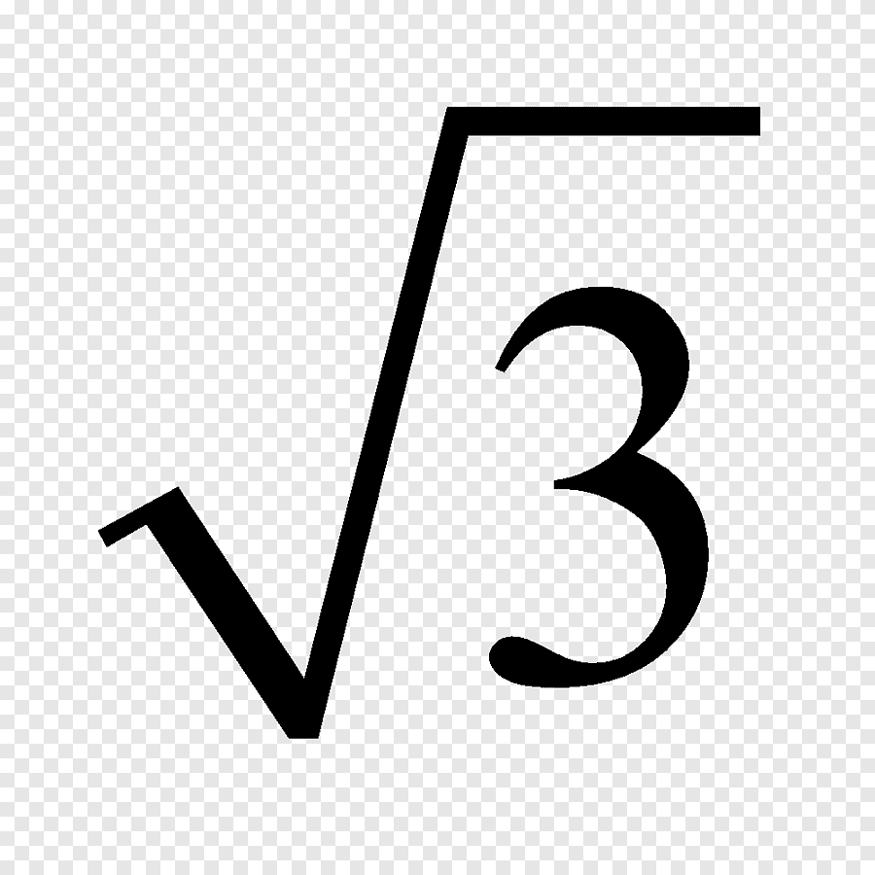PT Ratio: 66KV/ /110 V/



**PQZIP inside**

Continuous waveform recording Trigger free setup 5,000 power parameters @ 1/2 cycle resolution Easy deployment



**Class A**

Far surpassing the highest standards set by the industry, the BLACKBOX device series complies with standards for: aggregations, time clock uncertainty, flagging, and transient influence quantities**.**



**Superior Accuracy**

Elspec’s pioneering measurement method utilizes a dual-range gain of 2 x 16 Bit to yield, a superior accuracy far surpassing IEC 61000-4-30 Class A requirements, thereby capturing the finest details & deviations in Power Quality parameters.



**Synchronized Monitoring**

A unique time synchronization algorithm assures that logged data from multiple units is synchronized & displayed on the same time scale with typical ms resolution. Every event on a grid is accurately analyzed for precise root cause analysis, behavior propagation, and traced to its source.

**IEEE 519 – 2022 standard for Harmonics :**

The IEEE 519-2022 standard defines the voltage and current harmonics distortion criteria for the design of electrical systems. Goals for designing electrical systems that contain both linear and non-linear loads are established in this standard. The existed voltage and current waveforms in every part of the system are explained, and the waveform distortion goals for the system designer are established.

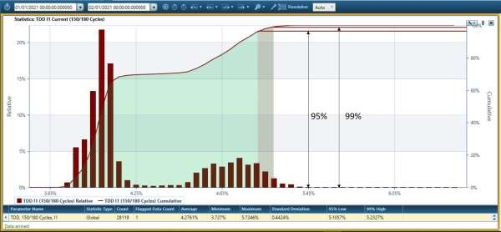

The IEEE 519 – 2022 compliance criteria

These suggested practice limits are for application at a point of common coupling (PCC) between the system owner or operator and system users. The PCC is often regarded as the point in the power system closest to the user where the system owner or operator could provide services to other users.

Voltage distortion limits Table 1 (IEEE 519-2022)

|  |  |  |  |  |
| --- | --- | --- | --- | --- |
| Description | Weekly 95th percentile short time | | Daily 99th percentile short time | |
| Bus voltage V at PCC | Individual harmonic (%) | THD (%) | Individual harmonic (%) | THD (%) |
| V ≤ 1.0 Kv | 5 | 8 | 7.5 | 12 |
| 1 kV < V ≤ 69 Kv | 3 | 5 | 4.5 | 7.5 |
| 69 kV < V ≤ 161 kV | 1.5 | 2.5 | 2.25 | 3.75 |
| >161 KV | 1 | 1.5 | 1.5 | 2.25 |

**Current distortion limits**

* Daily 99th percentile very short time (3 s) harmonic currents should be less than 2.0 times the values given in the tables below.
* Weekly 99th percentile short time (10 min) harmonic currents should be less than 1.5 times the values given in tables below.
* Weekly 95th percentile short time (10 min) harmonic currents should be less than the values given in tables below.

|  |  |  |  |  |  |  |
| --- | --- | --- | --- | --- | --- | --- |
| **Maximum harmonic current distortion in percent of IL** | | | | | | |
| **Individual harmonic order (odd harmonics)** | | | | | | |
| **Isc/IL** | **2 ≤ h < 11** | **11 ≤ h < 17** | **17 ≤ h < 23** | **23 ≤ h < 35** | **35 ≤ h** ≤ **50** | **TDD** |
| **<25** | 1.0 | 0.5 | 0.38 | 0.15 | 0.1 | 1.5 |
| **25 < 50** | 2.0 | 1.0 | 0.75 | 0.3 | 0.15 | 2.5 |
| **­> 50** | 3.0 | 1.5 | 1.15 | 0.45 | 0.22 | 3.75 |

<=6 : Even Harmonics are 50 % of the above table

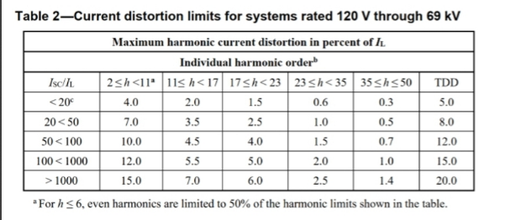

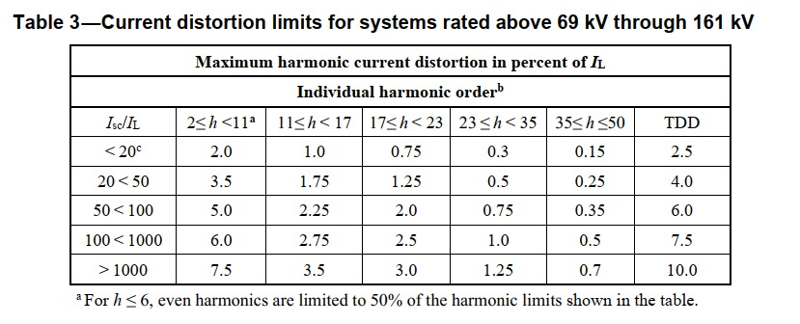

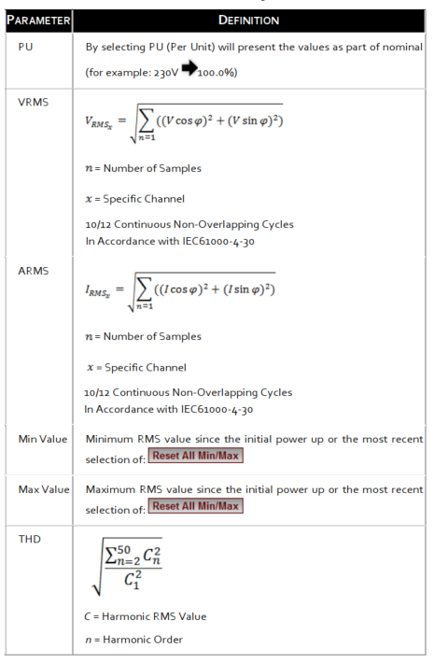

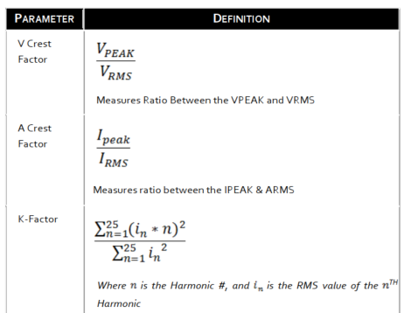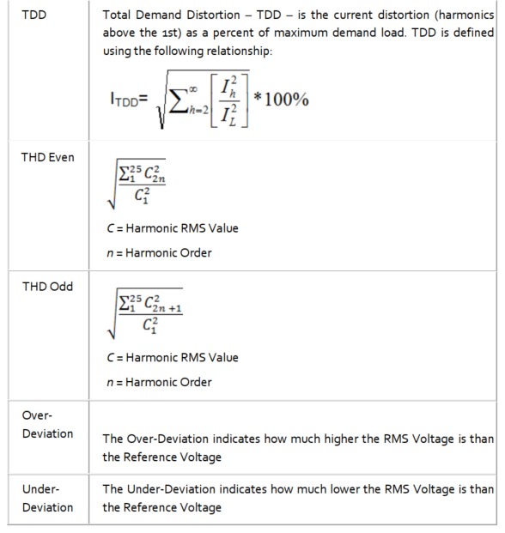

|  |  |  |  |  |  |
| --- | --- | --- | --- | --- | --- |
| **Sl.no** | **Date** | **From** | **Date** | **To** | **Description** |
| **1** | 06/05/2025 | 06:30 PM | 13/05/2025 | 06:30 PM | 7 Days Report |
| **2** | 06/05/2025 | 06:30 PM | 07/05/2025 | 06:00 AM | Day 1 Non-Generating Hours |
| **3** | 07/05/2025 | 06:00 AM | 07/05/2025 | 06:30 PM | Day 2 Generating Hours |
| **5** | 07/05/2025 | 06:30 PM | 08/05/2025 | 06:00 AM | Day 2 Non-Generating Hours |
| **6** | 08/05/2025 | 06:00 AM | 08/05/2025 | 06:30 PM | Day 3 Generating Hours |
| **7** | 08/05/2025 | 06:30 PM | 09/05/2025 | 06:00 AM | Day 3 Non-Generating Hours |
| **8** | 09/05/2025 | 06:00 AM | 09/05/2025 | 06:30 PM | Day 4 Generating Hours |
| **9** | 09/05/2025 | 06:30 PM | 10/05/2025 | 06:00 AM | Day 4 Non-Generating Hours |
| **10** | 10/05/2025 | 06:00 AM | 10/05/2025 | 06:30 PM | Day 5 Generating Hours |
| **11** | 10/05/2025 | 06:30 PM | 11/05/2025 | 06:00 AM | Day 5 Non-Generating Hours |
| **12** | 11/05/2025 | 06:00 AM | 11/05/2025 | 06:30 PM | Day 6 Generating Hours |
| **13** | 11/05/2025 | 06:00 PM | 12/05/2025 | 06:00 AM | Day 6 Non-Generating Hours |
| **14** | 12/05/2025 | 06:00 AM | 12/05/2025 | 06:30 PM | Day 7 Generating Hours |
| **15** | 12/05/2025 | 06:30 PM | 13/05/2025 | 06:00 AM | Day 7 Non-Generating Hours |
| **16** | 13/05/2025 | 06:00 AM | 13/05/2025 | 06:30 PM | Day 8 Generating Hours |

**Generating and Non-Generating Hours’ Time Table**

1. **Electrical : Power Supplies & Stabilizers**
   1. **Measurement**
2. **For Voltage Circuit PQ Parameter Measurement**
   1. **Total Harmonic Distortion in Voltage circuit (THD) for Very short time (3 second) values 99th percentile:**

|  |  |  |  |  |  |
| --- | --- | --- | --- | --- | --- |
| **Day** | **Recommended limit as per Standard IEEE 519- 2022 (%)** | **R Phase**  **(%)** | **Y Phase (%)** | **B Phase**  **(%)** | **Remarks** |
| 06-05-2025 | 7.5 | 0.971 | 0.927 | 0.869 | All values are within limits |
| 07-05-2025 | 1.127 | 1.055 | 0.999 |
| 08-05-2025 | 1.292 | 1.234 | 1.161 |
| 09-05-2025 | 1.067 | 1.022 | 0.952 |
| 10-05-2025 | 1.039 | 1.012 | 0.968 |
| 11-05-2025 | 1.207 | 1.227 | 1.105 |
| 12-05-2025 | 1.124 | 1.141 | 1.052 |
| 13-05-2025 | 1.098 | 1.01 | 1.011 |

1. **Total Harmonic Distortion in Voltage circuit (THD) for short time (10 minute) values 95th percentile:**

|  |  |  |  |  |
| --- | --- | --- | --- | --- |
| **Recommended limit as per Standard IEEE 519- 2022 (%)** | **R Phase (%)** | **Y Phase (%)** | **B Phase (%)** | **Remarks** |
| 5 | 1.087 | 1.069 | 1.012 | All values are within limits |

**3. Individual Voltage Harmonic distortion measurement for very short time (3second) values 99th percentile**

|  |  |  |  |  |  |  |  |  |  |  |
| --- | --- | --- | --- | --- | --- | --- | --- | --- | --- | --- |
| **Day – 1 Night Time (06/05/2025) (06:30 PM – 06:00 AM)** | | | | | | | | | | |
| Even Harmonic | Recommended Limits as per Std IEEE 519-2022 (%) | Measured max [%] | | | Odd Harmonic | Recommended Limits as per Std IEEE 519-2022 (%) | Measured max [%] | | | Remarks |
|  |  | **R** | **Y** | **B** |  |  | **R** | **Y** | **B** |  |
| 2 | **4.5** | 0.056 | 0.053 | 0.048 | **3** | **4.5** | 0.212 | 0.302 | 0.415 | All values are within limits. |
| 4 | 0.068 | 0.051 | 0.045 | **5** | 0.921 | 0.84 | 0.747 |
| 6 | 0.119 | 0.128 | 0.108 | **7** | 0.517 | 0.506 | 0.473 |
| 8 | 0.067 | 0.038 | 0.045 | **9** | 0.051 | 0.057 | 0.058 |
| 10 | 0.03 | 0.024 | 0.026 | **11** | 0.553 | 0.404 | 0.461 |
| 12 | 0.084 | 0.082 | 0.082 | **13** | 0.491 | 0.533 | 0.458 |
| 14 | 0.043 | 0.035 | 0.046 | **15** | 0.054 | 0.063 | 0.055 |
| 16 | 0.05 | 0.052 | 0.066 | **17** | 0.155 | 0.105 | 0.154 |
| 18 | 0.04 | 0.038 | 0.04 | **19** | 0.233 | 0.197 | 0.209 |
| 20 | 0.079 | 0.075 | 0.068 | **21** | 0.056 | 0.057 | 0.047 |
| 22 | 0.046 | 0.032 | 0.037 | **23** | 0.068 | 0.041 | 0.059 |
| 24 | 0.017 | 0.017 | 0.017 | **25** | 0.022 | 0.031 | 0.027 |
| 26 | 0.023 | 0.022 | 0.022 | **27** | 0.029 | 0.027 | 0.027 |
| 28 | 0.017 | 0.017 | 0.017 | **29** | 0.014 | 0.014 | 0.013 |
| 30 | 0.014 | 0.013 | 0.013 | **31** | 0.02 | 0.019 | 0.02 |
| 32 | 0.014 | 0.014 | 0.014 | **33** | 0.021 | 0.02 | 0.02 |
| 34 | 0.018 | 0.018 | 0.018 | **35** | 0.012 | 0.014 | 0.012 |
| 36 | 0 | 0 | 0 | **37** | 0.029 | 0.032 | 0.021 |
| 38 | 0.017 | 0.016 | 0.016 | **39** | 0.017 | 0.017 | 0.016 |
| 40 | 0.015 | 0.014 | 0.015 | **41** | 0.052 | 0.048 | 0.06 |
| 42 | 0.011 | 0.011 | 0.011 | **43** | 0.024 | 0.021 | 0.018 |
| 44 | 0.013 | 0.013 | 0.013 | **45** | 0.017 | 0.017 | 0.016 |
| 46 | 0.016 | 0.015 | 0.015 | **47** | 0.019 | 0.024 | 0.019 |
| 48 | 0.012 | 0.012 | 0.011 | **49** | 0.023 | 0.018 | 0.016 |
| 50 | 0.016 | 0.017 | 0.017 |  |  |  |  |  |

**3. Individual Voltage Harmonic distortion measurement for very short time (3second) values 99th percentile**

|  |  |  |  |  |  |  |  |  |  |  |
| --- | --- | --- | --- | --- | --- | --- | --- | --- | --- | --- |
| **Day 2 Day Time (07/05/2025) (06:00 AM – 06:30 PM)** | | | | | | | | | | |
| Even Harmonic | Recommended Limits as per Std IEEE 519-2022 (%) | Measured max [%] | | | Odd Harmonic | Recommended Limits as per Std IEEE 519-2022 (%) | Measured max [%] | | | Remarks |
|  |  | **R** | **Y** | **B** |  |  | **R** | **Y** | **B** |  |
| 2 | **4.5** | 0.134 | 0.124 | 0.098 | 3 | **4.5** | 0.156 | 0.203 | 0.356 | All values are within limits. |
| 4 | 0.059 | 0.083 | 0.072 | 5 | 0.601 | 0.462 | 0.487 |
| 6 | 0.128 | 0.125 | 0.124 | 7 | 0.334 | 0.309 | 0.263 |
| 8 | 0.064 | 0.06 | 0.064 | 9 | 0.03 | 0.042 | 0.04 |
| 10 | 0.059 | 0.056 | 0.06 | 11 | 0.166 | 0.21 | 0.233 |
| 12 | 0.087 | 0.084 | 0.085 | 13 | 0.362 | 0.354 | 0.298 |
| 14 | 0.063 | 0.063 | 0.062 | 15 | 0.039 | 0.037 | 0.047 |
| 16 | 0.049 | 0.048 | 0.046 | 17 | 0.134 | 0.155 | 0.144 |
| 18 | 0.04 | 0.043 | 0.04 | 19 | 0.144 | 0.146 | 0.145 |
| 20 | 0.082 | 0.072 | 0.092 | 21 | 0.034 | 0.039 | 0.04 |
| 22 | 0.097 | 0.102 | 0.101 | 23 | 0.121 | 0.13 | 0.116 |
| 24 | 0.04 | 0.047 | 0.06 | 25 | 0.169 | 0.169 | 0.159 |
| 26 | 0.127 | 0.129 | 0.114 | 27 | 0.044 | 0.055 | 0.06 |
| 28 | 0.095 | 0.1 | 0.109 | 29 | 0.104 | 0.12 | 0.092 |
| 30 | 0.04 | 0.055 | 0.051 | 31 | 0.141 | 0.117 | 0.126 |
| 32 | 0.103 | 0.105 | 0.087 | 33 | 0.057 | 0.062 | 0.062 |
| 34 | 0.178 | 0.176 | 0.168 | 35 | 0.178 | 0.188 | 0.173 |
| 36 | 0.108 | 0.103 | 0.105 | 37 | 0.17 | 0.166 | 0.21 |
| 38 | 0.26 | 0.253 | 0.236 | 39 | 0.056 | 0.083 | 0.077 |
| 40 | 0.161 | 0.154 | 0.184 | 41 | 0.147 | 0.156 | 0.146 |
| 42 | 0.055 | 0.078 | 0.063 | 43 | 0.138 | 0.134 | 0.134 |
| 44 | 0.073 | 0.074 | 0.062 | 45 | 0.029 | 0.033 | 0.035 |
| 46 | 0.12 | 0.123 | 0.129 | 47 | 0.069 | 0.084 | 0.08 |
| 48 | 0.03 | 0.032 | 0.039 | 49 | 0.068 | 0.071 | 0.058 |
| 50 | 0.142 | 0.144 | 0.133 |  |  |  |  |  |

**3. Individual Voltage Harmonic distortion measurement for very short time (3second) values 99th percentile**

|  |  |  |  |  |  |  |  |  |  |  |
| --- | --- | --- | --- | --- | --- | --- | --- | --- | --- | --- |
| **Day - 2** **Night Time** **(06:30 PM to 06:00 AM)** | | | | | | | | | | |
| Even Harmonic | Recommended Limits as per Std IEEE 519-2022 (%) | Measured max [%] | | | Odd Harmonic | Recommended Limits as per Std IEEE 519-2022 (%) | Measured max [%] | | | Remarks |
|  |  | **R** | **Y** | **B** |  |  | **R** | **Y** | **B** |  |
| 2 | **4.5** | 0.065 | 0.053 | 0.062 | **3** | **4.5** | 0.155 | 0.331 | 0.482 | All values are within limits. |
| 4 | 0.055 | 0.078 | 0.052 | **5** | 1.162 | 1.115 | 0.963 |
| 6 | 0.111 | 0.106 | 0.105 | **7** | 0.514 | 0.506 | 0.413 |
| 8 | 0.053 | 0.046 | 0.057 | **9** | 0.05 | 0.05 | 0.051 |
| 10 | 0.035 | 0.034 | 0.038 | **11** | 0.627 | 0.468 | 0.598 |
| 12 | 0.082 | 0.079 | 0.079 | **13** | 0.501 | 0.486 | 0.403 |
| 14 | 0.038 | 0.037 | 0.04 | **15** | 0.065 | 0.076 | 0.06 |
| 16 | 0.036 | 0.031 | 0.038 | **17** | 0.12 | 0.112 | 0.145 |
| 18 | 0.036 | 0.034 | 0.035 | **19** | 0.17 | 0.254 | 0.22 |
| 20 | 0.072 | 0.081 | 0.078 | **21** | 0.058 | 0.056 | 0.05 |
| 22 | 0.071 | 0.066 | 0.077 | **23** | 0.114 | 0.104 | 0.12 |
| 24 | 0.019 | 0.018 | 0.018 | **25** | 0.147 | 0.129 | 0.127 |
| 26 | 0.099 | 0.099 | 0.087 | **27** | 0.033 | 0.031 | 0.03 |
| 28 | 0.044 | 0.034 | 0.045 | **29** | 0.065 | 0.054 | 0.082 |
| 30 | 0.017 | 0.025 | 0.025 | **31** | 0.056 | 0.049 | 0.071 |
| 32 | 0.028 | 0.027 | 0.035 | **33** | 0.04 | 0.053 | 0.033 |
| 34 | 0.075 | 0.072 | 0.086 | **35** | 0.141 | 0.137 | 0.089 |
| 36 | 0.059 | 0.048 | 0.046 | **37** | 0.201 | 0.189 | 0.24 |
| 38 | 0.149 | 0.162 | 0.154 | **39** | 0.034 | 0.034 | 0.039 |
| 40 | 0.079 | 0.073 | 0.091 | **41** | 0.08 | 0.087 | 0.061 |
| 42 | 0.033 | 0.048 | 0.035 | **43** | 0.131 | 0.125 | 0.134 |
| 44 | 0.023 | 0.045 | 0.037 | **45** | 0.018 | 0.018 | 0.019 |
| 46 | 0.094 | 0.085 | 0.092 | **47** | 0.029 | 0.031 | 0.024 |
| 48 | 0.019 | 0.02 | 0.022 | **49** | 0.034 | 0.034 | 0.02 |
| 50 | 0.095 | 0.114 | 0.099 |  |  |  |  |  |

**3. Individual Voltage Harmonic distortion measurement for very short time (3second) values 99th percentile**

|  |  |  |  |  |  |  |  |  |  |  |
| --- | --- | --- | --- | --- | --- | --- | --- | --- | --- | --- |
| **Day 3 Day Time (08/05/2025) (06:00 AM – 06:30 PM)** | | | | | | | | | | |
| Even Harmonic | Recommended Limits as per Std IEEE 519-2022 (%) | Measured max [%] | | | Odd Harmonic | Recommended Limits as per Std IEEE 519-2022 (%) | Measured max [%] | | | Remarks |
|  |  | **R** | **Y** | **B** |  |  | **R** | **Y** | **B** |  |
| 2 | **4.5** | 0.131 | 0.122 | 0.092 | **3** | **4.5** | 0.148 | 0.291 | 0.406 | All values are within limits. |
| 4 | 0.053 | 0.076 | 0.073 | **5** | 0.613 | 0.495 | 0.491 |
| 6 | 0.125 | 0.121 | 0.12 | **7** | 0.311 | 0.315 | 0.254 |
| 8 | 0.055 | 0.052 | 0.048 | **9** | 0.033 | 0.045 | 0.042 |
| 10 | 0.058 | 0.053 | 0.062 | **11** | 0.278 | 0.238 | 0.251 |
| 12 | 0.089 | 0.086 | 0.087 | **13** | 0.272 | 0.215 | 0.2 |
| 14 | 0.064 | 0.067 | 0.063 | **15** | 0.037 | 0.031 | 0.036 |
| 16 | 0.054 | 0.046 | 0.049 | **17** | 0.129 | 0.151 | 0.139 |
| 18 | 0.039 | 0.041 | 0.039 | **19** | 0.16 | 0.163 | 0.163 |
| 20 | 0.077 | 0.071 | 0.071 | **21** | 0.036 | 0.045 | 0.04 |
| 22 | 0.086 | 0.092 | 0.1 | **23** | 0.131 | 0.135 | 0.144 |
| 24 | 0.041 | 0.051 | 0.067 | **25** | 0.175 | 0.163 | 0.174 |
| 26 | 0.124 | 0.13 | 0.105 | **27** | 0.047 | 0.059 | 0.056 |
| 28 | 0.079 | 0.095 | 0.112 | **29** | 0.114 | 0.122 | 0.12 |
| 30 | 0.055 | 0.073 | 0.066 | **31** | 0.156 | 0.146 | 0.167 |
| 32 | 0.112 | 0.108 | 0.083 | **33** | 0.058 | 0.086 | 0.071 |
| 34 | 0.193 | 0.178 | 0.196 | **35** | 0.213 | 0.23 | 0.219 |
| 36 | 0.111 | 0.102 | 0.108 | **37** | 0.176 | 0.215 | 0.222 |
| 38 | 0.265 | 0.263 | 0.24 | **39** | 0.06 | 0.076 | 0.085 |
| 40 | 0.155 | 0.148 | 0.181 | **41** | 0.146 | 0.159 | 0.162 |
| 42 | 0.057 | 0.072 | 0.068 | **43** | 0.123 | 0.122 | 0.123 |
| 44 | 0.071 | 0.066 | 0.07 | **45** | 0.035 | 0.035 | 0.033 |
| 46 | 0.123 | 0.129 | 0.134 | **47** | 0.084 | 0.08 | 0.086 |
| 48 | 0.032 | 0.032 | 0.04 | **49** | 0.078 | 0.087 | 0.068 |
| 50 | 0.142 | 0.149 | 0.133 |  |  |  |  |  |

**3. Individual Voltage Harmonic distortion measurement for very short time (3second) values 99th percentile**

|  |  |  |  |  |  |  |  |  |  |  |
| --- | --- | --- | --- | --- | --- | --- | --- | --- | --- | --- |
| **Day - 3** **Night Time** **(06:30 PM to 06:00 AM)** | | | | | | | | | | |
| Even Harmonic | Recommended Limits as per Std IEEE 519-2022 (%) | Measured max [%] | | | Odd Harmonic | Recommended Limits as per Std IEEE 519-2022 (%) | Measured max [%] | | | Remarks |
|  |  | **R** | **Y** | **B** |  |  | **R** | **Y** | **B** |  |
| 2 | **4.5** | 0.075 | 0.066 | 0.076 | **3** | **4.5** | 0.166 | 0.288 | 0.445 | All values are within limits. |
| 4 | 0.063 | 0.078 | 0.057 | **5** | 0.806 | 0.704 | 0.693 |
| 6 | 0.128 | 0.119 | 0.124 | **7** | 0.581 | 0.584 | 0.559 |
| 8 | 0.037 | 0.051 | 0.048 | **9** | 0.056 | 0.059 | 0.056 |
| 10 | 0.03 | 0.035 | 0.039 | **11** | 0.733 | 0.578 | 0.513 |
| 12 | 0.089 | 0.085 | 0.085 | **13** | 0.51 | 0.529 | 0.393 |
| 14 | 0.042 | 0.041 | 0.046 | **15** | 0.051 | 0.06 | 0.067 |
| 16 | 0.035 | 0.045 | 0.051 | **17** | 0.141 | 0.109 | 0.136 |
| 18 | 0.036 | 0.034 | 0.035 | **19** | 0.174 | 0.158 | 0.176 |
| 20 | 0.091 | 0.085 | 0.102 | **21** | 0.057 | 0.055 | 0.053 |
| 22 | 0.052 | 0.046 | 0.058 | **23** | 0.098 | 0.109 | 0.102 |
| 24 | 0.02 | 0.019 | 0.02 | **25** | 0.118 | 0.107 | 0.094 |
| 26 | 0.101 | 0.102 | 0.088 | **27** | 0.03 | 0.032 | 0.028 |
| 28 | 0.05 | 0.043 | 0.044 | **29** | 0.083 | 0.072 | 0.085 |
| 30 | 0.014 | 0.034 | 0.028 | **31** | 0.033 | 0.062 | 0.071 |
| 32 | 0.046 | 0.029 | 0.031 | **33** | 0.034 | 0.043 | 0.038 |
| 34 | 0.114 | 0.088 | 0.128 | **35** | 0.101 | 0.09 | 0.1 |
| 36 | 0.052 | 0.046 | 0.047 | **37** | 0.073 | 0.079 | 0.117 |
| 38 | 0.178 | 0.172 | 0.178 | **39** | 0.038 | 0.036 | 0.056 |
| 40 | 0.122 | 0.093 | 0.126 | **41** | 0.063 | 0.068 | 0.061 |
| 42 | 0.035 | 0.036 | 0.032 | **43** | 0.115 | 0.11 | 0.125 |
| 44 | 0.036 | 0.056 | 0.035 | **45** | 0.017 | 0.018 | 0.02 |
| 46 | 0.11 | 0.1 | 0.102 | **47** | 0.025 | 0.031 | 0.03 |
| 48 | 0.021 | 0.023 | 0.022 | **49** | 0.027 | 0.021 | 0.02 |
| 50 | 0.107 | 0.126 | 0.116 |  |  |  |  |  |

**3. Individual Voltage Harmonic distortion measurement for very short time (3second) values 99th percentile**

|  |  |  |  |  |  |  |  |  |  |  |
| --- | --- | --- | --- | --- | --- | --- | --- | --- | --- | --- |
| **Day 4 Day Time (09/05/2025) (06:00 AM – 06:30 PM)** | | | | | | | | | | |
| Even Harmonic | Recommended Limits as per Std IEEE 519-2022 (%) | Measured max [%] | | | Odd Harmonic | Recommended Limits as per Std IEEE 519-2022 (%) | Measured max [%] | | | Remarks |
|  |  | **R** | **Y** | **B** |  |  | **R** | **Y** | **B** |  |
| 2 | **4.5** | 0.141 | 0.131 | 0.095 | **3** | **4.5** | 0.157 | 0.246 | 0.355 | All values are within limits. |
| 4 | 0.057 | 0.083 | 0.081 | **5** | 0.517 | 0.435 | 0.457 |
| 6 | 0.122 | 0.117 | 0.118 | **7** | 0.334 | 0.318 | 0.279 |
| 8 | 0.055 | 0.047 | 0.049 | **9** | 0.035 | 0.05 | 0.045 |
| 10 | 0.063 | 0.058 | 0.066 | **11** | 0.147 | 0.174 | 0.166 |
| 12 | 0.089 | 0.084 | 0.086 | **13** | 0.267 | 0.262 | 0.262 |
| 14 | 0.065 | 0.075 | 0.069 | **15** | 0.04 | 0.033 | 0.04 |
| 16 | 0.063 | 0.052 | 0.053 | **17** | 0.115 | 0.14 | 0.129 |
| 18 | 0.037 | 0.045 | 0.042 | **19** | 0.149 | 0.154 | 0.153 |
| 20 | 0.098 | 0.072 | 0.095 | **21** | 0.037 | 0.047 | 0.04 |
| 22 | 0.098 | 0.1 | 0.105 | **23** | 0.15 | 0.154 | 0.163 |
| 24 | 0.045 | 0.059 | 0.076 | **25** | 0.183 | 0.173 | 0.18 |
| 26 | 0.129 | 0.135 | 0.115 | **27** | 0.045 | 0.066 | 0.059 |
| 28 | 0.089 | 0.107 | 0.119 | **29** | 0.139 | 0.143 | 0.144 |
| 30 | 0.061 | 0.075 | 0.078 | **31** | 0.181 | 0.174 | 0.194 |
| 32 | 0.099 | 0.134 | 0.105 | **33** | 0.058 | 0.092 | 0.076 |
| 34 | 0.193 | 0.185 | 0.185 | **35** | 0.204 | 0.219 | 0.221 |
| 36 | 0.111 | 0.09 | 0.109 | **37** | 0.179 | 0.2 | 0.24 |
| 38 | 0.283 | 0.28 | 0.259 | **39** | 0.053 | 0.085 | 0.099 |
| 40 | 0.176 | 0.168 | 0.202 | **41** | 0.147 | 0.147 | 0.164 |
| 42 | 0.06 | 0.066 | 0.07 | **43** | 0.121 | 0.121 | 0.119 |
| 44 | 0.073 | 0.07 | 0.076 | **45** | 0.033 | 0.036 | 0.034 |
| 46 | 0.121 | 0.13 | 0.135 | **47** | 0.083 | 0.083 | 0.086 |
| 48 | 0.031 | 0.031 | 0.04 | **49** | 0.085 | 0.094 | 0.073 |
| 50 | 0.145 | 0.151 | 0.14 |  |  |  |  |  |

**3. Individual Voltage Harmonic distortion measurement for very short time (3second) values 99th percentile**

|  |  |  |  |  |  |  |  |  |  |  |
| --- | --- | --- | --- | --- | --- | --- | --- | --- | --- | --- |
| **Day - 4** **Night Time** **(06:30 PM to 06:00 AM)** | | | | | | | | | | |
| Even Harmonic | Recommended Limits as per Std IEEE 519-2022 (%) | Measured max [%] | | | Odd Harmonic | Recommended Limits as per Std IEEE 519-2022 (%) | Measured max [%] | | | Remarks |
|  |  | **R** | **Y** | **B** |  |  | **R** | **Y** | **B** |  |
| 2 |  | 0.072 | 0.067 | 0.059 | **3** | **4.5** | 0.165 | 0.298 | 0.463 | All values are within limits. |
| 4 | 0.043 | 0.059 | 0.044 | **5** | 0.805 | 0.715 | 0.645 |
| 6 | 0.126 | 0.126 | 0.12 | **7** | 0.708 | 0.555 | 0.593 |
| 8 | 0.044 | 0.055 | 0.043 | **9** | 0.046 | 0.06 | 0.053 |
| 10 | 0.026 | 0.027 | 0.029 | **11** | 0.413 | 0.451 | 0.498 |
| 12 | 0.089 | 0.087 | 0.088 | **13** | 0.478 | 0.494 | 0.435 |
| 14 | 0.034 | 0.034 | 0.036 | **15** | 0.056 | 0.062 | 0.068 |
| 16 | 0.045 | 0.045 | 0.05 | **17** | 0.161 | 0.144 | 0.171 |
| 18 | 0.039 | 0.037 | 0.04 | **19** | 0.241 | 0.241 | 0.238 |
| 20 | 0.105 | 0.107 | 0.104 | **21** | 0.062 | 0.053 | 0.059 |
| 22 | 0.064 | 0.058 | 0.067 | **23** | 0.105 | 0.087 | 0.1 |
| 24 | 0.025 | 0.024 | 0.025 | **25** | 0.131 | 0.122 | 0.11 |
| 26 | 0.075 | 0.074 | 0.065 | **27** | 0.031 | 0.033 | 0.033 |
| 28 | 0.037 | 0.036 | 0.044 | **29** | 0.071 | 0.076 | 0.096 |
| 30 | 0.016 | 0.026 | 0.027 | **31** | 0.052 | 0.037 | 0.062 |
| 32 | 0.037 | 0.033 | 0.036 | **33** | 0.05 | 0.042 | 0.029 |
| 34 | 0.059 | 0.057 | 0.048 | **35** | 0.099 | 0.112 | 0.109 |
| 36 | 0.056 | 0.053 | 0.049 | **37** | 0.153 | 0.141 | 0.178 |
| 38 | 0.098 | 0.101 | 0.109 | **39** | 0.036 | 0.036 | 0.036 |
| 40 | 0.073 | 0.065 | 0.07 | **41** | 0.078 | 0.088 | 0.076 |
| 42 | 0.032 | 0.046 | 0.036 | **43** | 0.135 | 0.13 | 0.133 |
| 44 | 0.019 | 0.044 | 0.043 | **45** | 0.017 | 0.018 | 0.017 |
| 46 | 0.076 | 0.065 | 0.066 | **47** | 0.025 | 0.032 | 0.029 |
| 48 | 0.019 | 0.017 | 0.02 | **49** | 0.023 | 0.022 | 0.015 |
| 50 | 0.094 | 0.112 | 0.094 |  |  |  |  |  |

**3. Individual Voltage Harmonic distortion measurement for very short time (3second) values 99th percentile**

|  |  |  |  |  |  |  |  |  |  |  |
| --- | --- | --- | --- | --- | --- | --- | --- | --- | --- | --- |
| **Day 5 Day Time (10/05/2025) (06:00 AM – 06:30 PM)** | | | | | | | | | | |
| Even Harmonic | Recommended Limits as per Std IEEE 519-2022 (%) | Measured max [%] | | | Odd Harmonic | Recommended Limits as per Std IEEE 519-2022 (%) | Measured max [%] | | | Remarks |
|  |  | **R** | **Y** | **B** |  |  | **R** | **Y** | **B** |  |
| 2 | **4.5** | 0.139 | 0.128 | 0.094 | **3** | **4.5** | 0.151 | 0.265 | 0.371 | All values are within limits. |
| 4 | 0.054 | 0.082 | 0.079 | **5** | 0.572 | 0.493 | 0.534 |
| 6 | 0.122 | 0.118 | 0.117 | **7** | 0.288 | 0.278 | 0.234 |
| 8 | 0.052 | 0.043 | 0.05 | **9** | 0.055 | 0.058 | 0.045 |
| 10 | 0.059 | 0.056 | 0.075 | **11** | 0.446 | 0.405 | 0.418 |
| 12 | 0.086 | 0.082 | 0.085 | **13** | 0.295 | 0.297 | 0.253 |
| 14 | 0.064 | 0.071 | 0.067 | **15** | 0.037 | 0.032 | 0.038 |
| 16 | 0.063 | 0.052 | 0.053 | **17** | 0.12 | 0.136 | 0.132 |
| 18 | 0.037 | 0.044 | 0.042 | **19** | 0.156 | 0.155 | 0.156 |
| 20 | 0.085 | 0.076 | 0.081 | **21** | 0.034 | 0.043 | 0.045 |
| 22 | 0.109 | 0.102 | 0.108 | **23** | 0.125 | 0.121 | 0.118 |
| 24 | 0.042 | 0.05 | 0.066 | **25** | 0.176 | 0.157 | 0.168 |
| 26 | 0.14 | 0.138 | 0.116 | **27** | 0.041 | 0.058 | 0.052 |
| 28 | 0.09 | 0.1 | 0.115 | **29** | 0.112 | 0.119 | 0.107 |
| 30 | 0.034 | 0.05 | 0.062 | **31** | 0.147 | 0.127 | 0.132 |
| 32 | 0.102 | 0.11 | 0.086 | **33** | 0.061 | 0.091 | 0.07 |
| 34 | 0.211 | 0.185 | 0.198 | **35** | 0.196 | 0.24 | 0.217 |
| 36 | 0.107 | 0.09 | 0.109 | **37** | 0.187 | 0.243 | 0.258 |
| 38 | 0.278 | 0.273 | 0.258 | **39** | 0.062 | 0.073 | 0.079 |
| 40 | 0.179 | 0.172 | 0.203 | **41** | 0.154 | 0.15 | 0.122 |
| 42 | 0.056 | 0.063 | 0.064 | **43** | 0.141 | 0.127 | 0.136 |
| 44 | 0.077 | 0.074 | 0.071 | **45** | 0.035 | 0.035 | 0.036 |
| 46 | 0.125 | 0.135 | 0.144 | **47** | 0.071 | 0.065 | 0.063 |
| 48 | 0.03 | 0.029 | 0.038 | **49** | 0.056 | 0.052 | 0.041 |
| 50 | 0.15 | 0.161 | 0.142 |  |  |  |  |  |

**3. Individual Voltage Harmonic distortion measurement for very short time (3second) values 99th percentile**

|  |  |  |  |  |  |  |  |  |  |  |
| --- | --- | --- | --- | --- | --- | --- | --- | --- | --- | --- |
| **Day - 5** **Night Time** **(06:30 PM to 06:00 AM)** | | | | | | | | | | |
| Even Harmonic | Recommended Limits as per Std IEEE 519-2022 (%) | Measured max [%] | | | Odd Harmonic | Recommended Limits as per Std IEEE 519-2022 (%) | Measured max [%] | | | Remarks |
|  |  | **R** | **Y** | **B** |  |  | **R** | **Y** | **B** |  |
| 2 | **4.5** | 0.048 | 0.048 | 0.041 | **3** | **4.5** | 0.183 | 0.331 | 0.45 | All values are within limits. |
| 4 | 0.042 | 0.043 | 0.044 | **5** | 1.03 | 0.954 | 0.846 |
| 6 | 0.123 | 0.117 | 0.118 | **7** | 0.482 | 0.481 | 0.449 |
| 8 | 0.036 | 0.034 | 0.035 | **9** | 0.041 | 0.052 | 0.05 |
| 10 | 0.025 | 0.025 | 0.026 | **11** | 0.613 | 0.466 | 0.567 |
| 12 | 0.087 | 0.084 | 0.085 | **13** | 0.491 | 0.456 | 0.333 |
| 14 | 0.034 | 0.033 | 0.034 | **15** | 0.057 | 0.062 | 0.055 |
| 16 | 0.043 | 0.044 | 0.047 | **17** | 0.166 | 0.145 | 0.189 |
| 18 | 0.037 | 0.035 | 0.035 | **19** | 0.155 | 0.175 | 0.178 |
| 20 | 0.089 | 0.087 | 0.085 | **21** | 0.065 | 0.068 | 0.049 |
| 22 | 0.071 | 0.063 | 0.072 | **23** | 0.118 | 0.096 | 0.104 |
| 24 | 0.024 | 0.023 | 0.024 | **25** | 0.026 | 0.027 | 0.027 |
| 26 | 0.023 | 0.022 | 0.023 | **27** | 0.027 | 0.026 | 0.026 |
| 28 | 0.014 | 0.013 | 0.014 | **29** | 0.015 | 0.015 | 0.014 |
| 30 | 0.016 | 0.015 | 0.015 | **31** | 0.02 | 0.02 | 0.02 |
| 32 | 0.014 | 0.014 | 0.014 | **33** | 0.022 | 0.021 | 0.021 |
| 34 | 0.02 | 0.02 | 0.018 | **35** | 0.038 | 0.03 | 0.031 |
| 36 | 0.01 | 0.007 | 0.007 | **37** | 0.039 | 0.069 | 0.038 |
| 38 | 0.027 | 0.028 | 0.027 | **39** | 0.022 | 0.025 | 0.021 |
| 40 | 0.026 | 0.021 | 0.026 | **41** | 0.075 | 0.068 | 0.06 |
| 42 | 0.011 | 0.011 | 0.011 | **43** | 0.031 | 0.029 | 0.028 |
| 44 | 0.015 | 0.014 | 0.014 | **45** | 0.016 | 0.017 | 0.016 |
| 46 | 0.015 | 0.014 | 0.015 | **47** | 0.022 | 0.031 | 0.027 |
| 48 | 0.011 | 0.011 | 0.011 | **49** | 0.023 | 0.022 | 0.019 |
| 50 | 0.017 | 0.018 | 0.019 |  |  |  |  |  |

**3. Individual Voltage Harmonic distortion measurement for very short time (3second) values 99th percentile**

|  |  |  |  |  |  |  |  |  |  |  |
| --- | --- | --- | --- | --- | --- | --- | --- | --- | --- | --- |
| **Day 6 Day Time (11/05/2025) (06:00 AM – 06:30 PM)** | | | | | | | | | | |
| Even Harmonic | Recommended Limits as per Std IEEE 519-2022 (%) | Measured max [%] | | | Odd Harmonic | Recommended Limits as per Std IEEE 519-2022 (%) | Measured max [%] | | | Remarks |
|  |  | **R** | **Y** | **B** |  |  | **R** | **Y** | **B** |  |
| 2 | **4.5** | 0.126 | 0.116 | 0.088 | **3** | **4.5** | 0.152 | 0.274 | 0.393 | All values are within limits. |
| 4 | 0.054 | 0.081 | 0.073 | **5** | 0.743 | 0.651 | 0.621 |
| 6 | 0.118 | 0.11 | 0.111 | **7** | 0.402 | 0.376 | 0.309 |
| 8 | 0.052 | 0.043 | 0.048 | **9** | 0.03 | 0.045 | 0.041 |
| 10 | 0.059 | 0.052 | 0.063 | **11** | 0.388 | 0.373 | 0.437 |
| 12 | 0.086 | 0.079 | 0.082 | **13** | 0.335 | 0.311 | 0.264 |
| 14 | 0.061 | 0.068 | 0.061 | **15** | 0.033 | 0.033 | 0.036 |
| 16 | 0.054 | 0.047 | 0.053 | **17** | 0.115 | 0.121 | 0.13 |
| 18 | 0.034 | 0.042 | 0.04 | **19** | 0.148 | 0.192 | 0.185 |
| 20 | 0.073 | 0.071 | 0.066 | **21** | 0.03 | 0.041 | 0.042 |
| 22 | 0.098 | 0.101 | 0.101 | **23** | 0.136 | 0.131 | 0.125 |
| 24 | 0.045 | 0.051 | 0.062 | **25** | 0.163 | 0.166 | 0.16 |
| 26 | 0.138 | 0.131 | 0.109 | **27** | 0.04 | 0.059 | 0.063 |
| 28 | 0.087 | 0.103 | 0.11 | **29** | 0.122 | 0.117 | 0.146 |
| 30 | 0.042 | 0.054 | 0.061 | **31** | 0.145 | 0.129 | 0.13 |
| 32 | 0.134 | 0.111 | 0.093 | **33** | 0.057 | 0.071 | 0.073 |
| 34 | 0.2 | 0.195 | 0.207 | **35** | 0.226 | 0.261 | 0.24 |
| 36 | 0.111 | 0.11 | 0.108 | **37** | 0.207 | 0.243 | 0.252 |
| 38 | 0.281 | 0.299 | 0.278 | **39** | 0.063 | 0.076 | 0.089 |
| 40 | 0.166 | 0.157 | 0.19 | **41** | 0.151 | 0.157 | 0.143 |
| 42 | 0.057 | 0.08 | 0.068 | **43** | 0.117 | 0.115 | 0.12 |
| 44 | 0.068 | 0.068 | 0.067 | **45** | 0.035 | 0.035 | 0.041 |
| 46 | 0.114 | 0.122 | 0.126 | **47** | 0.069 | 0.065 | 0.065 |
| 48 | 0.03 | 0.034 | 0.037 | **49** | 0.055 | 0.066 | 0.053 |
| 50 | 0.139 | 0.141 | 0.127 |  |  |  |  |  |

**3. Individual Voltage Harmonic distortion measurement for very short time (3second) values 99th percentile**

|  |  |  |  |  |  |  |  |  |  |  |
| --- | --- | --- | --- | --- | --- | --- | --- | --- | --- | --- |
| **Day - 6** **Night Time** **(06:30 PM to 06:00 AM)** | | | | | | | | | | |
| Even Harmonic | Recommended Limits as per Std IEEE 519-2022 (%) | Measured max [%] | | | Odd Harmonic | Recommended Limits as per Std IEEE 519-2022 (%) | Measured max [%] | | | Remarks |
|  |  | **R** | **Y** | **B** |  |  | **R** | **Y** | **B** |  |
| 2 | **4.5** | 0.068 | 0.07 | 0.068 | **3** | **4.5** | 0.146 | 0.36 | 0.487 | All values are within limits. |
| 4 | 0.06 | 0.054 | 0.056 | **5** | 1.004 | 0.98 | 0.804 |
| 6 | 0.133 | 0.12 | 0.125 | **7** | 0.539 | 0.515 | 0.453 |
| 8 | 0.077 | 0.099 | 0.077 | **9** | 0.053 | 0.052 | 0.059 |
| 10 | 0.038 | 0.032 | 0.029 | **11** | 0.564 | 0.52 | 0.549 |
| 12 | 0.088 | 0.085 | 0.085 | **13** | 0.362 | 0.35 | 0.346 |
| 14 | 0.034 | 0.029 | 0.033 | **15** | 0.045 | 0.058 | 0.056 |
| 16 | 0.051 | 0.043 | 0.049 | **17** | 0.137 | 0.123 | 0.169 |
| 18 | 0.037 | 0.037 | 0.036 | **19** | 0.186 | 0.208 | 0.175 |
| 20 | 0.102 | 0.087 | 0.094 | **21** | 0.084 | 0.053 | 0.056 |
| 22 | 0.089 | 0.076 | 0.087 | **23** | 0.138 | 0.108 | 0.115 |
| 24 | 0.026 | 0.025 | 0.026 | **25** | 0.086 | 0.063 | 0.069 |
| 26 | 0.048 | 0.045 | 0.041 | **27** | 0.024 | 0.025 | 0.025 |
| 28 | 0.043 | 0.027 | 0.035 | **29** | 0.062 | 0.069 | 0.066 |
| 30 | 0.018 | 0.019 | 0.018 | **31** | 0.046 | 0.039 | 0.058 |
| 32 | 0.022 | 0.025 | 0.029 | **33** | 0.044 | 0.025 | 0.046 |
| 34 | 0.035 | 0.044 | 0.031 | **35** | 0.1 | 0.076 | 0.083 |
| 36 | 0.042 | 0.03 | 0.035 | **37** | 0.142 | 0.161 | 0.146 |
| 38 | 0.047 | 0.042 | 0.037 | **39** | 0.026 | 0.043 | 0.034 |
| 40 | 0.035 | 0.041 | 0.043 | **41** | 0.088 | 0.095 | 0.067 |
| 42 | 0.028 | 0.022 | 0.024 | **43** | 0.052 | 0.048 | 0.05 |
| 44 | 0.014 | 0.014 | 0.014 | **45** | 0.017 | 0.018 | 0.018 |
| 46 | 0.02 | 0.019 | 0.022 | **47** | 0.02 | 0.027 | 0.024 |
| 48 | 0.014 | 0.011 | 0.016 | **49** | 0.025 | 0.022 | 0.02 |
| 50 | 0.018 | 0.022 | 0.022 |  |  |  |  |  |

**3. Individual Voltage Harmonic distortion measurement for very short time (3second) values 99th percentile**

|  |  |  |  |  |  |  |  |  |  |  |
| --- | --- | --- | --- | --- | --- | --- | --- | --- | --- | --- |
| **Day 7 Day Time (12/05/2025) (06:00 AM – 06:30 PM)** | | | | | | | | | | |
| Even Harmonic | Recommended Limits as per Std IEEE 519-2022 (%) | Measured max [%] | | | Odd Harmonic | Recommended Limits as per Std IEEE 519-2022 (%) | Measured max [%] | | | Remarks |
|  |  | **R** | **Y** | **B** |  |  | **R** | **Y** | **B** |  |
| 2 | **4.5** | 0.134 | 0.113 | 0.09 | **3** | **4.5** | 0.146 | 0.238 | 0.343 | All values are within limits. |
| 4 | 0.054 | 0.078 | 0.07 | **5** | 0.491 | 0.393 | 0.407 |
| 6 | 0.127 | 0.123 | 0.12 | **7** | 0.329 | 0.313 | 0.288 |
| 8 | 0.055 | 0.052 | 0.045 | **9** | 0.032 | 0.04 | 0.035 |
| 10 | 0.058 | 0.055 | 0.058 | **11** | 0.268 | 0.255 | 0.248 |
| 12 | 0.068 | 0.065 | 0.068 | **13** | 0.244 | 0.221 | 0.218 |
| 14 | 0.056 | 0.061 | 0.059 | **15** | 0.03 | 0.028 | 0.036 |
| 16 | 0.052 | 0.046 | 0.051 | **17** | 0.114 | 0.133 | 0.124 |
| 18 | 0.024 | 0.028 | 0.027 | **19** | 0.154 | 0.153 | 0.152 |
| 20 | 0.071 | 0.068 | 0.069 | **21** | 0.035 | 0.039 | 0.037 |
| 22 | 0.097 | 0.101 | 0.097 | **23** | 0.126 | 0.124 | 0.122 |
| 24 | 0.041 | 0.04 | 0.061 | **25** | 0.155 | 0.139 | 0.143 |
| 26 | 0.135 | 0.135 | 0.116 | **27** | 0.043 | 0.056 | 0.049 |
| 28 | 0.089 | 0.108 | 0.112 | **29** | 0.102 | 0.104 | 0.093 |
| 30 | 0.045 | 0.046 | 0.053 | **31** | 0.155 | 0.116 | 0.135 |
| 32 | 0.119 | 0.116 | 0.091 | **33** | 0.06 | 0.085 | 0.076 |
| 34 | 0.19 | 0.188 | 0.194 | **35** | 0.244 | 0.229 | 0.206 |
| 36 | 0.109 | 0.094 | 0.102 | **37** | 0.225 | 0.286 | 0.275 |
| 38 | 0.26 | 0.272 | 0.241 | **39** | 0.066 | 0.073 | 0.081 |
| 40 | 0.152 | 0.156 | 0.181 | **41** | 0.142 | 0.161 | 0.154 |
| 42 | 0.056 | 0.062 | 0.057 | **43** | 0.115 | 0.11 | 0.115 |
| 44 | 0.07 | 0.07 | 0.065 | **45** | 0.027 | 0.032 | 0.031 |
| 46 | 0.11 | 0.121 | 0.123 | **47** | 0.066 | 0.065 | 0.069 |
| 48 | 0.03 | 0.027 | 0.034 | **49** | 0.062 | 0.061 | 0.049 |
| 50 | 0.144 | 0.157 | 0.134 |  |  |  |  |  |

**3. Individual Voltage Harmonic distortion measurement for very short time (3second) values 99th percentile**

|  |  |  |  |  |  |  |  |  |  |  |
| --- | --- | --- | --- | --- | --- | --- | --- | --- | --- | --- |
| **Day - 7** **Night Time** **(06:30 PM to 06:00 AM)** | | | | | | | | | | |
| Even Harmonic | Recommended Limits as per Std IEEE 519-2022 (%) | Measured max [%] | | | Odd Harmonic | Recommended Limits as per Std IEEE 519-2022 (%) | Measured max [%] | | | Remarks |
|  |  | **R** | **Y** | **B** |  |  | **R** | **Y** | **B** |  |
| 2 | **4.5** | 0.186 | 0.158 | 0.225 | **3** | **4.5** | 0.193 | 0.355 | 0.506 | All values are within limits. |
| 4 | 0.114 | 0.154 | 0.157 | **5** | 0.86 | 0.752 | 0.672 |
| 6 | 0.147 | 0.144 | 0.12 | **7** | 0.613 | 0.616 | 0.564 |
| 8 | 0.148 | 0.174 | 0.139 | **9** | 0.058 | 0.068 | 0.079 |
| 10 | 0.072 | 0.06 | 0.073 | **11** | 0.696 | 0.606 | 0.695 |
| 12 | 0.085 | 0.081 | 0.082 | **13** | 0.407 | 0.421 | 0.332 |
| 14 | 0.056 | 0.06 | 0.057 | **15** | 0.076 | 0.09 | 0.068 |
| 16 | 0.063 | 0.056 | 0.075 | **17** | 0.102 | 0.103 | 0.122 |
| 18 | 0.07 | 0.058 | 0.06 | **19** | 0.244 | 0.208 | 0.207 |
| 20 | 0.128 | 0.124 | 0.109 | **21** | 0.066 | 0.068 | 0.065 |
| 22 | 0.103 | 0.095 | 0.102 | **23** | 0.105 | 0.087 | 0.099 |
| 24 | 0.025 | 0.03 | 0.022 | **25** | 0.124 | 0.11 | 0.106 |
| 26 | 0.041 | 0.043 | 0.045 | **27** | 0.029 | 0.04 | 0.04 |
| 28 | 0.062 | 0.052 | 0.066 | **29** | 0.081 | 0.079 | 0.064 |
| 30 | 0.018 | 0.018 | 0.022 | **31** | 0.05 | 0.037 | 0.047 |
| 32 | 0.064 | 0.08 | 0.076 | **33** | 0.058 | 0.03 | 0.05 |
| 34 | 0.043 | 0.059 | 0.04 | **35** | 0.106 | 0.081 | 0.123 |
| 36 | 0.045 | 0.048 | 0.039 | **37** | 0.137 | 0.083 | 0.152 |
| 38 | 0.054 | 0.056 | 0.049 | **39** | 0.036 | 0.037 | 0.061 |
| 40 | 0.075 | 0.074 | 0.078 | **41** | 0.077 | 0.077 | 0.073 |
| 42 | 0.026 | 0.026 | 0.027 | **43** | 0.065 | 0.052 | 0.076 |
| 44 | 0.05 | 0.052 | 0.058 | **45** | 0.016 | 0.017 | 0.016 |
| 46 | 0.038 | 0.035 | 0.036 | **47** | 0.025 | 0.043 | 0.043 |
| 48 | 0.018 | 0.023 | 0.022 | **49** | 0.052 | 0.044 | 0.044 |
| 50 | 0.063 | 0.085 | 0.072 |  |  |  |  |  |

**3. Individual Voltage Harmonic distortion measurement for very short time (3second) values 99th percentile**

|  |  |  |  |  |  |  |  |  |  |  |
| --- | --- | --- | --- | --- | --- | --- | --- | --- | --- | --- |
| **Day 8 Day Time (13/05/2025) (06:00 AM – 06:30 PM)** | | | | | | | | | | |
| Even Harmonic | Recommended Limits as per Std IEEE 519-2022 (%) | Measured max [%] | | | Odd Harmonic | Recommended Limits as per Std IEEE 519-2022 (%) | Measured max [%] | | | Remarks |
|  |  | **R** | **Y** | **B** |  |  | **R** | **Y** | **B** |  |
| 2 | **4.5** | 0.14 | 0.132 | 0.092 | 3 | **4.5** | 0.155 | 0.32 | 0.419 | All values are within limits. |
| 4 | 0.068 | 0.094 | 0.092 | 5 | 0.491 | 0.394 | 0.365 |
| 6 | 0.116 | 0.113 | 0.114 | 7 | 0.623 | 0.499 | 0.527 |
| 8 | 0.054 | 0.044 | 0.045 | 9 | 0.04 | 0.059 | 0.056 |
| 10 | 0.06 | 0.055 | 0.066 | 11 | 0.272 | 0.263 | 0.248 |
| 12 | 0.08 | 0.076 | 0.077 | 13 | 0.377 | 0.362 | 0.313 |
| 14 | 0.062 | 0.068 | 0.064 | 15 | 0.032 | 0.041 | 0.037 |
| 16 | 0.054 | 0.049 | 0.051 | 17 | 0.146 | 0.144 | 0.14 |
| 18 | 0.036 | 0.035 | 0.036 | 19 | 0.18 | 0.234 | 0.217 |
| 20 | 0.08 | 0.068 | 0.089 | 21 | 0.03 | 0.045 | 0.036 |
| 22 | 0.096 | 0.109 | 0.099 | 23 | 0.132 | 0.121 | 0.129 |
| 24 | 0.045 | 0.042 | 0.058 | 25 | 0.173 | 0.165 | 0.162 |
| 26 | 0.14 | 0.123 | 0.099 | 27 | 0.039 | 0.05 | 0.042 |
| 28 | 0.09 | 0.109 | 0.111 | 29 | 0.134 | 0.13 | 0.118 |
| 30 | 0.046 | 0.039 | 0.05 | 31 | 0.186 | 0.175 | 0.194 |
| 32 | 0.163 | 0.12 | 0.118 | 33 | 0.061 | 0.059 | 0.059 |
| 34 | 0.234 | 0.224 | 0.244 | 35 | 0.183 | 0.219 | 0.205 |
| 36 | 0.107 | 0.091 | 0.103 | 37 | 0.181 | 0.177 | 0.212 |
| 38 | 0.273 | 0.28 | 0.253 | 39 | 0.065 | 0.066 | 0.066 |
| 40 | 0.162 | 0.152 | 0.174 | 41 | 0.142 | 0.153 | 0.111 |
| 42 | 0.057 | 0.072 | 0.065 | 43 | 0.115 | 0.119 | 0.117 |
| 44 | 0.078 | 0.072 | 0.064 | 45 | 0.031 | 0.032 | 0.035 |
| 46 | 0.124 | 0.139 | 0.135 | 47 | 0.074 | 0.074 | 0.069 |
| 48 | 0.031 | 0.031 | 0.037 | 49 | 0.068 | 0.071 | 0.051 |
| 50 | 0.148 | 0.159 | 0.139 |  |  |  |  |  |

**4. Individual Voltage Harmonic distortion measurement for short time (10 Minutes) values 95th percentile**

|  |  |  |  |  |  |  |  |  |  |  |
| --- | --- | --- | --- | --- | --- | --- | --- | --- | --- | --- |
| **7 Days From (06-05-2025 06:30:00 PM to 13-05-2025 06:30:00 PM)** | | | | | | | | | | |
| Even Harmonic | Recommended Limits as per Std IEEE 519-2022 (%) | Measured max [%] | | | Odd Harmonic | Recommended Limits as per Std IEEE 519-2022 (%) | Measured max [%] | | | Remarks |
|  |  | **R** | **Y** | **B** |  |  | **R** | **Y** | **B** |  |
| 2 | **3.0** | 0.121 | 0.112 | 0.072 | **3** | **3.0** | 0.141 | 0.301 | 0.431 | All values are within limits. |
| 4 | 0.043 | 0.071 | 0.066 | **5** | 0.883 | 0.835 | 0.717 |
| 6 | 0.105 | 0.101 | 0.101 | **7** | 0.487 | 0.464 | 0.483 |
| 8 | 0.044 | 0.037 | 0.041 | **9** | 0.029 | 0.035 | 0.034 |
| 10 | 0.052 | 0.048 | 0.053 | **11** | 0.514 | 0.426 | 0.468 |
| 12 | 0.073 | 0.07 | 0.071 | **13** | 0.445 | 0.461 | 0.37 |
| 14 | 0.056 | 0.059 | 0.057 | **15** | 0.037 | 0.044 | 0.039 |
| 16 | 0.049 | 0.042 | 0.046 | **17** | 0.114 | 0.116 | 0.119 |
| 18 | 0.031 | 0.031 | 0.031 | **19** | 0.171 | 0.166 | 0.152 |
| 20 | 0.068 | 0.063 | 0.065 | **21** | 0.033 | 0.038 | 0.032 |
| 22 | 0.083 | 0.087 | 0.091 | **23** | 0.099 | 0.1 | 0.092 |
| 24 | 0.037 | 0.032 | 0.049 | **25** | 0.147 | 0.14 | 0.145 |
| 26 | 0.116 | 0.111 | 0.089 | **27** | 0.031 | 0.035 | 0.034 |
| 28 | 0.067 | 0.077 | 0.092 | **29** | 0.09 | 0.083 | 0.073 |
| 30 | 0.03 | 0.032 | 0.039 | **31** | 0.112 | 0.097 | 0.106 |
| 32 | 0.084 | 0.088 | 0.067 | **33** | 0.039 | 0.048 | 0.041 |
| 34 | 0.167 | 0.163 | 0.164 | **35** | 0.145 | 0.142 | 0.142 |
| 36 | 0.068 | 0.055 | 0.074 | **37** | 0.131 | 0.133 | 0.154 |
| 38 | 0.251 | 0.249 | 0.227 | **39** | 0.043 | 0.048 | 0.055 |
| 40 | 0.137 | 0.121 | 0.148 | **41** | 0.123 | 0.126 | 0.092 |
| 42 | 0.035 | 0.039 | 0.042 | **43** | 0.101 | 0.096 | 0.098 |
| 44 | 0.063 | 0.058 | 0.052 | **45** | 0.024 | 0.026 | 0.025 |
| 46 | 0.107 | 0.112 | 0.119 | **47** | 0.051 | 0.051 | 0.05 |
| 48 | 0.021 | 0.018 | 0.027 | **49** | 0.043 | 0.044 | 0.034 |
| 50 | 0.133 | 0.135 | 0.123 |  |  |  |  |  |

**Flicker Measurement**

1. **Short term Flicker (Pst) measurement values 95th percentile**

|  |  |  |  |  |
| --- | --- | --- | --- | --- |
| Recommended limit as per Standard IEEE 1453- 2015 & IEC 61000-4-15 (%) | R Phase  (%) | Y Phase  (%) | B Phase  (%) | Remarks |
| 0.9 | 0.158 | 0.176 | 0.179 | All Phase values are Within Limits |

1. **Long term Flicker (Plt) measurement values 95th percentile**

|  |  |  |  |  |
| --- | --- | --- | --- | --- |
| **Recommended limit as per Standard IEEE 1453- 2015 & IEC 61000-4-15 (%)** | **R Phase**  **(%)** | **Y Phase**  **(%)** | **B Phase**  **(%)** | **Remarks** |
| 0.7 | 0.493 | 0.412 | 0.474 | All Phase values are Within Limits |

1. **Short term Flicker (Pst) measurement values 99th percentile**

|  |  |  |  |  |
| --- | --- | --- | --- | --- |
| **Recommended limit as per Standard IEEE 1453- 2015 & IEC 61000-4-15 (%)** | **R Phase**  **(%)** | **Y Phase**  **(%)** | **B Phase**  **(%)** | **Remarks** |
| 1.35 | 0.89 | 0.518 | 0.601 | All Phase values are Within Limits |

1. **Long term Flicker (Plt) measurement values 99th percentile**

|  |  |  |  |  |
| --- | --- | --- | --- | --- |
| **Recommended limit as per Standard IEEE 1453- 2015 & IEC 61000-4-15 (%)** | **R Phase**  **(%)** | **Y Phase**  **(%)** | **B Phase**  **(%)** | **Remarks** |
| 1.05 | 1.136 | 0.782 | 1.064 | All Phase values are  within Limits Except R & B Phase |

1. **For Current Circuit PQ Parameter Measurement**
2. **Total Harmonic Distortion in Current circuit (THD)/ Total Demand Distortion in Current circuit (TDD) for Very short time (3 second) values 99th percentile:**

|  |  |  |  |  |  |
| --- | --- | --- | --- | --- | --- |
| **Day** | **Recommended limit as per Standard IEEE 519- 2022**  **(%)** | **R Phase**  **(%)** | **Y Phase**  **(%)** | **B Phase**  **(%)** | **Remarks** |
| 06-05-2025 | 10 | 0.837 | 0.748 | 0.819 | All values are within limits |
| 07-05-2025 | 0.974 | 0.895 | 0.931 |
| 08-05-2025 | 0.979 | 0.894 | 0.955 |
| 09-05-2025 | 0.981 | 0.934 | 0.761 |
| 10-05-2025 | 0.999 | 0.975 | 0.865 |
| 11-05-2025 | 1.003 | 0.989 | 0.962 |
| 12-05-2025 | 1.068 | 0.986 | 1.033 |
| 13-05-2025 | 1.192 | 1.048 | 1.164 |

1. **Total Harmonic Distortion in Current circuit (THD)/ Total Demand Distortion in Current circuit (TDD) for short time (10Minute) values 99th percentile:**

|  |  |  |  |  |
| --- | --- | --- | --- | --- |
| **Recommended limit as per Standard IEEE 519- 2022**  **(%)** | **R Phase**  **(%)** | **Y Phase**  **(%)** | **B Phase**  **(%)** | **Remarks** |
| 7.5 | 1.156 | 1.018 | 1.131 | The values are within Limits |

1. **Total Harmonic Distortion in Current circuit (THD)/ Total Demand Distortion in Current circuit (TDD) for short time (10Minute) values 95th percentile:**

|  |  |  |  |  |
| --- | --- | --- | --- | --- |
| **Recommended limit as per Standard IEEE 519- 2022**  **(%)** | **R Phase**  **(%)** | **Y Phase**  **(%)** | **B Phase**  **(%)** | **Remarks** |
| 5 | 0.962 | 0.91 | 0.931 | The values are within Limits |

**4. Individual Current Harmonic distortion measurement for very short time (3second) values 99th percentile**

|  |  |  |  |  |  |  |  |  |  |  |
| --- | --- | --- | --- | --- | --- | --- | --- | --- | --- | --- |
| **Day – 1 Night Time (06/05/2025) (06:30 PM – 06:00 AM)** | | | | | | | | | | |
| Even Harmonic | Recommended Limits as per Std IEEE 519-2022 (%) | Measured max [%] | | | Odd Harmonic | Recommended Limits as per Std IEEE 519-2022 (%) | Measured max [%] | | | Remarks |
|  |  | **R** | **Y** | **B** |  |  | **R** | **Y** | **B** |  |
| 2 | **4** | 0.04 | 0.028 | 0.032 | 3 | **8** | 0.3 | 0.521 | 0.271 | All values are within limits |
| 4 | 0 | 0 | 0 | 5 | 0.817 | 0.598 | 0.824 |
| 6 | 0 | 0 | 0 | 7 | 0.423 | 0.329 | 0.4 |
| 8 | **8** | 0 | 0 | 0 | 9 | 0 | 0 | 0 |
| 10 | 0 | 0 | 0 | 11 | **4** | 0 | 0 | 0 |
| 12 | **4** | 0 | 0 | 0 | 13 | 0 | 0 | 0 |
| 14 | 0 | 0 | 0 | 15 | 0 | 0 | 0 |
| 16 | 0 | 0 | 0 | 17 | **3** | 0 | 0 | 0 |
| 18 | **3** | 0 | 0 | 0 | 19 | 0 | 0 | 0 |
| 20 | 0 | 0 | 0 | 21 | 0 | 0 | 0 |
| 22 | 0 | 0 | 0 | 23 | **1.2** | 0 | 0 | 0 |
| 24 | **1.2** | 0 | 0 | 0 | 25 | 0 | 0 | 0 |
| 26 | 0 | 0 | 0 | 27 | 0 | 0 | 0 |
| 28 | 0 | 0 | 0 | 29 | 0 | 0 | 0 |
| 30 | 0 | 0 | 0 | 31 | 0 | 0 | 0 |
| 32 | 0 | 0 | 0 | 33 | 0 | 0 | 0 |
| 34 | 0 | 0 | 0 | 35 | **0.6** | 0 | 0 | 0 |
| 36 | **0.6** | 0 | 0 | 0 | 37 | 0 | 0 | 0 |
| 38 | 0 | 0 | 0 | 39 | 0 | 0 | 0 |
| 40 | 0 | 0 | 0 | 41 | 0 | 0 | 0 |
| 42 | 0 | 0 | 0 | 43 | 0 | 0 | 0 |
| 44 | 0 | 0 | 0 | 45 | 0 | 0 | 0 |
| 46 | 0 | 0 | 0 | 47 | 0 | 0 | 0 |
| 48 | 0 | 0 | 0 | 49 | 0 | 0 | 0 |
| 50 | 0 | 0 | 0 |  |  |  |  |  |

**4. Individual Current Harmonic distortion measurement for very short time (3second) values 99th percentile**

|  |  |  |  |  |  |  |  |  |  |  |
| --- | --- | --- | --- | --- | --- | --- | --- | --- | --- | --- |
| **Day – 2** **Day time** **(07/05/2025) (06:00 AM – 06:30 PM)** | | | | | | | | | | |
| Even Harmonic | Recommended Limits as per Std IEEE 519-2022 (%) | Measured max [%] | | | Odd Harmonic | Recommended Limits as per Std IEEE 519-2022 (%) | Measured max [%] | | | Remarks |
|  |  | **R** | **Y** | **B** |  |  | **R** | **Y** | **B** |  |
| 2 | **4** | 0.777 | 0.675 | 0.389 | 3 | **8** | 0.518 | 0.48 | 0.318 | All values are within limits. |
| 4 | 0.224 | 0.157 | 0.187 | 5 | 0.657 | 0.633 | 0.656 |
| 6 | 0 | 0 | 0 | 7 | 0.449 | 0.469 | 0.484 |
| 8 | **8** | 0 | 0 | 0 | 9 | 0 | 0 | 0 |
| 10 | 0 | 0 | 0 | 11 | **4** | 0 | 0.147 | 0.155 |
| 12 | **4** | 0 | 0 | 0 | 13 | 0 | 0 | 0 |
| 14 | 0 | 0 | 0 | 15 | 0 | 0 | 0 |
| 16 | 0 | 0 | 0 | 17 | **3** | 0 | 0 | 0 |
| 18 | **3** | 0 | 0 | 0 | 19 | 0 | 0 | 0 |
| 20 | 0 | 0 | 0 | 21 | 0 | 0 | 0 |
| 22 | 0 | 0 | 0 | 23 | **1.2** | 0 | 0 | 0 |
| 24 | **1.2** | 0 | 0 | 0 | 25 | 0 | 0 | 0 |
| 26 | 0 | 0 | 0 | 27 | 0 | 0 | 0 |
| 28 | 0 | 0 | 0 | 29 | 0 | 0 | 0 |
| 30 | 0 | 0 | 0 | 31 | 0 | 0 | 0 |
| 32 | 0 | 0 | 0 | 33 | 0 | 0 | 0 |
| 34 | 0 | 0 | 0 | 35 | **0.6** | 0 | 0 | 0 |
| 36 | **0.6** | 0 | 0 | 0 | 37 | 0 | 0 | 0 |
| 38 | 0 | 0 | 0 | 39 | 0 | 0 | 0 |
| 40 | 0 | 0 | 0 | 41 | 0 | 0 | 0 |
| 42 | 0 | 0 | 0 | 43 | 0 | 0 | 0 |
| 44 | 0 | 0 | 0 | 45 | 0 | 0 | 0 |
| 46 | 0 | 0 | 0 | 47 | 0 | 0 | 0 |
| 48 | 0 | 0 | 0 | 49 | 0 | 0 | 0 |
| 50 | 0 | 0 | 0 |  |  |  |  |  |

**4. Individual Current Harmonic distortion measurement for very short time (3second) values 99th percentile**

|  |  |  |  |  |  |  |  |  |  |  |
| --- | --- | --- | --- | --- | --- | --- | --- | --- | --- | --- |
| **Day - 2** **Night Time** **(06:30 PM to 06:00 AM)** | | | | | | | | | | |
| Even Harmonic | Recommended Limits as per Std IEEE 519-2022 (%) | Measured max [%] | | | Odd Harmonic | Recommended Limits as per Std IEEE 519-2022 (%) | Measured max [%] | | | Remarks |
|  |  | **R** | **Y** | **B** |  |  | **R** | **Y** | **B** |  |
| 2 | **4** | 0.232 | 0.13 | 0.171 | 3 | **8** | 0.308 | 0.529 | 0.272 | All values are within limits. |
| 4 | 0 | 0 | 0 | 5 | 0.843 | 0.621 | 0.853 |
| 6 | 0 | 0 | 0 | 7 | 0.441 | 0.345 | 0.413 |
| 8 | **8** | 0 | 0 | 0 | 9 | 0 | 0 | 0 |
| 10 | 0 | 0 | 0 | 11 | **4** | 0 | 0 | 0 |
| 12 | **4** | 0 | 0 | 0 | 13 | 0 | 0 | 0 |
| 14 | 0 | 0 | 0 | 15 | 0 | 0 | 0 |
| 16 | 0 | 0 | 0 | 17 | **3** | 0 | 0 | 0 |
| 18 | **3** | 0 | 0 | 0 | 19 | 0 | 0 | 0 |
| 20 | 0 | 0 | 0 | 21 | 0 | 0 | 0 |
| 22 | 0 | 0 | 0 | 23 | **1.2** | 0 | 0 | 0 |
| 24 | **1.2** | 0 | 0 | 0 | 25 | 0 | 0 | 0 |
| 26 | 0 | 0 | 0 | 27 | 0 | 0 | 0 |
| 28 | 0 | 0 | 0 | 29 | 0 | 0 | 0 |
| 30 | 0 | 0 | 0 | 31 | 0 | 0 | 0 |
| 32 | 0 | 0 | 0 | 33 | 0 | 0 | 0 |
| 34 | 0 | 0 | 0 | 35 | **0.6** | 0 | 0 | 0 |
| 36 | **0.6** | 0 | 0 | 0 | 37 | 0 | 0 | 0 |
| 38 | 0 | 0 | 0 | 39 | 0 | 0 | 0 |
| 40 | 0 | 0 | 0 | 41 | 0 | 0 | 0 |
| 42 | 0 | 0 | 0 | 43 | 0 | 0 | 0 |
| 44 | 0 | 0 | 0 | 45 | 0 | 0 | 0 |
| 46 | 0 | 0 | 0 | 47 | 0 | 0 | 0 |
| 48 | 0 | 0 | 0 | 49 | 0 | 0 | 0 |
| 50 | 0 | 0 | 0 |  |  |  |  |  |

**4. Individual Current Harmonic distortion measurement for very short time (3second) values 99th percentile**

|  |  |  |  |  |  |  |  |  |  |  |
| --- | --- | --- | --- | --- | --- | --- | --- | --- | --- | --- |
| **Day - 3** **Day time** **(08/05/2025) (06:00 AM – 06:30 PM)** | | | | | | | | | | |
| Even Harmonic | Recommended Limits as per Std IEEE 519-2022 (%) | Measured max [%] | | | Odd Harmonic | Recommended Limits as per Std IEEE 519-2022 (%) | Measured max [%] | | | Remarks |
|  |  | **R** | **Y** | **B** |  |  | **R** | **Y** | **B** |  |
| 2 | **4** | 0.747 | 0.624 | 0.374 | 3 | **8** | 0.536 | 0.486 | 0.339 | All values are within limits. |
| 4 | 0.223 | 0.145 | 0.187 | 5 | 0.716 | 0.668 | 0.719 |
| 6 | 0 | 0 | 0 | 7 | 0.453 | 0.445 | 0.471 |
| 8 | **8** | 0 | 0 | 0 | 9 | 0 | 0 | 0 |
| 10 | 0 | 0 | 0 | 11 | **4** | 0 | 0 | 0 |
| 12 | **4** | 0 | 0 | 0 | 13 | 0 | 0 | 0 |
| 14 | 0 | 0 | 0 | 15 | 0 | 0 | 0 |
| 16 | 0 | 0 | 0 | 17 | **3** | 0 | 0 | 0 |
| 18 | **3** | 0 | 0 | 0 | 19 | 0 | 0 | 0 |
| 20 | 0 | 0 | 0 | 21 | 0 | 0 | 0 |
| 22 | 0 | 0 | 0 | 23 | **1.2** | 0 | 0 | 0 |
| 24 | **1.2** | 0 | 0 | 0 | 25 | 0 | 0 | 0 |
| 26 | 0 | 0 | 0 | 27 | 0 | 0 | 0 |
| 28 | 0 | 0 | 0 | 29 | 0 | 0 | 0 |
| 30 | 0 | 0 | 0 | 31 | 0 | 0 | 0 |
| 32 | 0 | 0 | 0 | 33 | 0 | 0 | 0 |
| 34 | 0 | 0 | 0 | 35 | **0.6** | 0 | 0 | 0 |
| 36 | **0.6** | 0 | 0 | 0 | 37 | 0 | 0 | 0 |
| 38 | 0 | 0 | 0 | 39 | 0 | 0 | 0 |
| 40 | 0 | 0 | 0 | 41 | 0 | 0 | 0 |
| 42 | 0 | 0 | 0 | 43 | 0 | 0 | 0 |
| 44 | 0 | 0 | 0 | 45 | 0 | 0 | 0 |
| 46 | 0 | 0 | 0 | 47 | 0 | 0 | 0 |
| 48 | 0 | 0 | 0 | 49 | 0 | 0 | 0 |
| 50 | 0 | 0 | 0 |  |  |  |  |  |

**4. Individual Current Harmonic distortion measurement for very short time (3second) values 99th percentile**

|  |  |  |  |  |  |  |  |  |  |  |
| --- | --- | --- | --- | --- | --- | --- | --- | --- | --- | --- |
| **Day - 3** **Night Time** **(06:30 PM to 06:00 AM)** | | | | | | | | | | |
| Even Harmonic | Recommended Limits as per Std IEEE 519-2022 (%) | Measured max [%] | | | Odd Harmonic | Recommended Limits as per Std IEEE 519-2022 (%) | Measured max [%] | | | Remarks |
|  |  | **R** | **Y** | **B** |  |  | **R** | **Y** | **B** |  |
| 2 | **4** | 0.262 | 0.138 | 0.192 | 3 | **8** | 0.251 | 0.458 | 0.24 | All values are within limits. |
| 4 | 0.14 | 0 | 0 | 5 | 0.661 | 0.474 | 0.661 |
| 6 | 0 | 0 | 0 | 7 | 0.331 | 0.246 | 0.315 |
| 8 | **8** | 0 | 0 | 0 | 9 | 0 | 0 | 0 |
| 10 | 0 | 0 | 0 | 11 | **4** | 0 | 0 | 0 |
| 12 | **4** | 0 | 0 | 0 | 13 | 0 | 0 | 0 |
| 14 | 0 | 0 | 0 | 15 | 0 | 0 | 0 |
| 16 | 0 | 0 | 0 | 17 | **3** | 0 | 0 | 0 |
| 18 | **3** | 0 | 0 | 0 | 19 | 0 | 0 | 0 |
| 20 | 0 | 0 | 0 | 21 | 0 | 0 | 0 |
| 22 | 0 | 0 | 0 | 23 | **1.2** | 0 | 0 | 0 |
| 24 | **1.2** | 0 | 0 | 0 | 25 | 0 | 0 | 0 |
| 26 | 0 | 0 | 0 | 27 | 0 | 0 | 0 |
| 28 | 0 | 0 | 0 | 29 | 0 | 0 | 0 |
| 30 | 0 | 0 | 0 | 31 | 0 | 0 | 0 |
| 32 | 0 | 0 | 0 | 33 | 0 | 0 | 0 |
| 34 | 0 | 0 | 0 | 35 | **0.6** | 0 | 0 | 0 |
| 36 | **0.6** | 0 | 0 | 0 | 37 | 0 | 0 | 0 |
| 38 | 0 | 0 | 0 | 39 | 0 | 0 | 0 |
| 40 | 0 | 0 | 0 | 41 | 0 | 0 | 0 |
| 42 | 0 | 0 | 0 | 43 | 0 | 0 | 0 |
| 44 | 0 | 0 | 0 | 45 | 0 | 0 | 0 |
| 46 | 0 | 0 | 0 | 47 | 0 | 0 | 0 |
| 48 | 0 | 0 | 0 | 49 | 0 | 0 | 0 |
| 50 | 0 | 0 | 0 |  |  |  |  |  |

**4. Individual Current Harmonic distortion measurement for very short time (3second) values 99th percentile**

|  |  |  |  |  |  |  |  |  |  |  |
| --- | --- | --- | --- | --- | --- | --- | --- | --- | --- | --- |
| **Day - 4** **Day time** **(09/05/2025) (06:00 AM – 06:30 PM)** | | | | | | | | | | |
| Even Harmonic | Recommended Limits as per Std IEEE 519-2022 (%) | Measured max [%] | | | Odd Harmonic | Recommended Limits as per Std IEEE 519-2022 (%) | Measured max [%] | | | Remarks |
|  |  | **R** | **Y** | **B** |  |  | **R** | **Y** | **B** |  |
| 2 | **4** | 0.822 | 0.715 | 0.38 | 3 | **8** | 0.51 | 0.494 | 0.303 | All values are within limits. |
| 4 | 0.222 | 0.156 | 0.221 | 5 | 0.57 | 0.674 | 0.574 |
| 6 | 0 | 0 | 0 | 7 | 0.46 | 0.429 | 0.465 |
| 8 | **8** | 0 | 0 | 0 | 9 | 0 | 0 | 0 |
| 10 | 0 | 0 | 0 | 11 | **4** | 0 | 0.156 | 0.154 |
| 12 | **4** | 0 | 0 | 0 | 13 | 0 | 0 | 0 |
| 14 | 0 | 0 | 0 | 15 | 0 | 0 | 0 |
| 16 | 0 | 0 | 0 | 17 | **3** | 0 | 0 | 0 |
| 18 | **3** | 0 | 0 | 0 | 19 | 0 | 0 | 0 |
| 20 | 0 | 0 | 0 | 21 | 0 | 0 | 0 |
| 22 | 0 | 0 | 0 | 23 | **1.2** | 0 | 0 | 0 |
| 24 | **1.2** | 0 | 0 | 0 | 25 | 0 | 0 | 0 |
| 26 | 0 | 0 | 0 | 27 | 0 | 0 | 0 |
| 28 | 0 | 0 | 0 | 29 | 0 | 0 | 0 |
| 30 | 0 | 0 | 0 | 31 | 0 | 0 | 0 |
| 32 | 0 | 0 | 0 | 33 | 0 | 0 | 0 |
| 34 | 0 | 0 | 0 | 35 | **0.6** | 0 | 0 | 0 |
| 36 | **0.6** | 0 | 0 | 0 | 37 | 0 | 0 | 0 |
| 38 | 0 | 0 | 0 | 39 | 0 | 0 | 0 |
| 40 | 0 | 0 | 0 | 41 | 0 | 0 | 0 |
| 42 | 0 | 0 | 0 | 43 | 0 | 0 | 0 |
| 44 | 0 | 0 | 0 | 45 | 0 | 0 | 0 |
| 46 | 0 | 0 | 0 | 47 | 0 | 0 | 0 |
| 48 | 0 | 0 | 0 | 49 | 0 | 0 | 0 |
| 50 | 0 | 0 | 0 |  |  |  |  |  |

**4. Individual Current Harmonic distortion measurement for very short time (3second) values 99th percentile**

|  |  |  |  |  |  |  |  |  |  |  |
| --- | --- | --- | --- | --- | --- | --- | --- | --- | --- | --- |
| **Day - 4** **Night Time** **(06:30 PM to 06:00 AM)** | | | | | | | | | | |
| Even Harmonic | Recommended Limits as per Std IEEE 519-2022 (%) | Measured max [%] | | | Odd Harmonic | Recommended Limits as per Std IEEE 519-2022 (%) | Measured max [%] | | | Remarks |
|  |  | **R** | **Y** | **B** |  |  | **R** | **Y** | **B** |  |
| 2 | **4** | 0.217 | 0.11 | 0.174 | 3 | **8** | 0.292 | 0.509 | 0.26 | All values are within limits. |
| 4 | 0 | 0 | 0 | 5 | 0.775 | 0.563 | 0.778 |
| 6 | 0 | 0 | 0 | 7 | 0.402 | 0.306 | 0.376 |
| 8 | **8** | 0 | 0 | 0 | 9 | 0 | 0 | 0 |
| 10 | 0 | 0 | 0 | 11 | **4** | 0 | 0 | 0 |
| 12 | **4** | 0 | 0 | 0 | 13 | 0 | 0 | 0 |
| 14 | 0 | 0 | 0 | 15 | 0 | 0 | 0 |
| 16 | 0 | 0 | 0 | 17 | **3** | 0 | 0 | 0 |
| 18 | **3** | 0 | 0 | 0 | 19 | 0 | 0 | 0 |
| 20 | 0 | 0 | 0 | 21 | 0 | 0 | 0 |
| 22 | 0 | 0 | 0 | 23 | **1.2** | 0 | 0 | 0 |
| 24 | **1.2** | 0 | 0 | 0 | 25 | 0 | 0 | 0 |
| 26 | 0 | 0 | 0 | 27 | 0 | 0 | 0 |
| 28 | 0 | 0 | 0 | 29 | 0 | 0 | 0 |
| 30 | 0 | 0 | 0 | 31 | 0 | 0 | 0 |
| 32 | 0 | 0 | 0 | 33 | 0 | 0 | 0 |
| 34 | 0 | 0 | 0 | 35 | **0.6** | 0 | 0 | 0 |
| 36 | **0.6** | 0 | 0 | 0 | 37 | 0 | 0 | 0 |
| 38 | 0 | 0 | 0 | 39 | 0 | 0 | 0 |
| 40 | 0 | 0 | 0 | 41 | 0 | 0 | 0 |
| 42 | 0 | 0 | 0 | 43 | 0 | 0 | 0 |
| 44 | 0 | 0 | 0 | 45 | 0 | 0 | 0 |
| 46 | 0 | 0 | 0 | 47 | 0 | 0 | 0 |
| 48 | 0 | 0 | 0 | 49 | 0 | 0 | 0 |
| 50 | 0 | 0 | 0 |  |  |  |  |  |

**4. Individual Current Harmonic distortion measurement for very short time (3second) values 99th percentile**

|  |  |  |  |  |  |  |  |  |  |  |
| --- | --- | --- | --- | --- | --- | --- | --- | --- | --- | --- |
| **Day - 5** **Day time** **(10/05/2025) (06:00 AM – 06:30 PM)** | | | | | | | | | | |
| Even Harmonic | Recommended Limits as per Std IEEE 519-2022 (%) | Measured max [%] | | | Odd Harmonic | Recommended Limits as per Std IEEE 519-2022 (%) | Measured max [%] | | | Remarks |
|  |  | **R** | **Y** | **B** |  |  | **R** | **Y** | **B** |  |
| 2 | **4** | 0.78 | 0.684 | 0.429 | 3 | **8** | 0.566 | 0.499 | 0.325 | All values are within limits. |
| 4 | 0.214 | 0.153 | 0.201 | 5 | 0.718 | 0.698 | 0.774 |
| 6 | 0 | 0 | 0 | 7 | 0.5 | 0.522 | 0.56 |
| 8 | **8** | 0 | 0 | 0 | 9 | 0 | 0 | 0 |
| 10 | 0 | 0 | 0 | 11 | **4** | 0.141 | 0.148 | 0.151 |
| 12 | **4** | 0 | 0 | 0 | 13 | 0 | 0 | 0 |
| 14 | 0 | 0 | 0 | 15 | 0 | 0 | 0 |
| 16 | 0 | 0 | 0 | 17 | **3** | 0 | 0 | 0 |
| 18 | **3** | 0 | 0 | 0 | 19 | 0 | 0 | 0 |
| 20 | 0 | 0 | 0 | 21 | 0 | 0 | 0 |
| 22 | 0 | 0 | 0 | 23 | **1.2** | 0 | 0 | 0 |
| 24 | **1.2** | 0 | 0 | 0 | 25 | 0 | 0 | 0 |
| 26 | 0 | 0 | 0 | 27 | 0 | 0 | 0 |
| 28 | 0 | 0 | 0 | 29 | 0 | 0 | 0 |
| 30 | 0 | 0 | 0 | 31 | 0 | 0 | 0 |
| 32 | 0 | 0 | 0 | 33 | 0 | 0 | 0 |
| 34 | 0 | 0 | 0 | 35 | **0.6** | 0 | 0 | 0 |
| 36 | **0.6** | 0 | 0 | 0 | 37 | 0 | 0 | 0 |
| 38 | 0 | 0 | 0 | 39 | 0 | 0 | 0 |
| 40 | 0 | 0 | 0 | 41 | 0 | 0 | 0 |
| 42 | 0 | 0 | 0 | 43 | 0 | 0 | 0 |
| 44 | 0 | 0 | 0 | 45 | 0 | 0 | 0 |
| 46 | 0 | 0 | 0 | 47 | 0 | 0 | 0 |
| 48 | 0 | 0 | 0 | 49 | 0 | 0 | 0 |
| 50 | 0 | 0 | 0 |  |  |  |  |  |

**4. Individual Current Harmonic distortion measurement for very short time (3second) values 99th percentile**

|  |  |  |  |  |  |  |  |  |  |  |
| --- | --- | --- | --- | --- | --- | --- | --- | --- | --- | --- |
| **Day - 5** **Night Time** **(06:30 PM to 06:00 AM)** | | | | | | | | | | |
| Even Harmonic | Recommended Limits as per Std IEEE 519-2022 (%) | Measured max [%] | | | Odd Harmonic | Recommended Limits as per Std IEEE 519-2022 (%) | Measured max [%] | | | Remarks |
|  |  | **R** | **Y** | **B** |  |  | **R** | **Y** | **B** |  |
| 2 | **4** | 0.037 | 0.027 | 0.032 | 3 | **8** | 0.305 | 0.522 | 0.267 | All values are within limits. |
| 4 | 0 | 0 | 0 | 5 | 0.825 | 0.603 | 0.829 |
| 6 | 0 | 0 | 0 | 7 | 0.432 | 0.334 | 0.403 |
| 8 | **8** | 0 | 0 | 0 | 9 | 0 | 0 | 0 |
| 10 | 0 | 0 | 0 | 11 | **4** | 0 | 0 | 0 |
| 12 | **4** | 0 | 0 | 0 | 13 | 0 | 0 | 0 |
| 14 | 0 | 0 | 0 | 15 | 0 | 0 | 0 |
| 16 | 0 | 0 | 0 | 17 | **3** | 0 | 0 | 0 |
| 18 | **3** | 0 | 0 | 0 | 19 | 0 | 0 | 0 |
| 20 | 0 | 0 | 0 | 21 | 0 | 0 | 0 |
| 22 | 0 | 0 | 0 | 23 | **1.2** | 0 | 0 | 0 |
| 24 | **1.2** | 0 | 0 | 0 | 25 | 0 | 0 | 0 |
| 26 | 0 | 0 | 0 | 27 | 0 | 0 | 0 |
| 28 | 0 | 0 | 0 | 29 | 0 | 0 | 0 |
| 30 | 0 | 0 | 0 | 31 | 0 | 0 | 0 |
| 32 | 0 | 0 | 0 | 33 | 0 | 0 | 0 |
| 34 | 0 | 0 | 0 | 35 | **0.6** | 0 | 0 | 0 |
| 36 | **0.6** | 0 | 0 | 0 | 37 | 0 | 0 | 0 |
| 38 | 0 | 0 | 0 | 39 | 0 | 0 | 0 |
| 40 | 0 | 0 | 0 | 41 | 0 | 0 | 0 |
| 42 | 0 | 0 | 0 | 43 | 0 | 0 | 0 |
| 44 | 0 | 0 | 0 | 45 | 0 | 0 | 0 |
| 46 | 0 | 0 | 0 | 47 | 0 | 0 | 0 |
| 48 | 0 | 0 | 0 | 49 | 0 | 0 | 0 |
| 50 | 0 | 0 | 0 |  |  |  |  |  |

**4. Individual Current Harmonic distortion measurement for very short time (3second) values 99th percentile**

|  |  |  |  |  |  |  |  |  |  |  |
| --- | --- | --- | --- | --- | --- | --- | --- | --- | --- | --- |
| **Day - 6** **Day time** **(11/05/2025) (06:00 AM – 06:30 PM)** | | | | | | | | | | |
| Even Harmonic | Recommended Limits as per Std IEEE 519-2022 (%) | Measured max [%] | | | Odd Harmonic | Recommended Limits as per Std IEEE 519-2022 (%) | Measured max [%] | | | Remarks |
|  |  | **R** | **Y** | **B** |  |  | **R** | **Y** | **B** |  |
| 2 | **4** | 0.296 | 0.38 | 0.368 | 3 | **8** | 0.553 | 0.523 | 0.326 | All values are within limits. |
| 4 | 0 | 0.207 | 0.175 | 5 | 0.679 | 0.749 | 0.696 |
| 6 | 0 | 0 | 0 | 7 | 0.461 | 0.49 | 0.514 |
| 8 | **8** | 0 | 0 | 0 | 9 | 0 | 0 | 0 |
| 10 | 0 | 0 | 0 | 11 | **4** | 0.159 | 0.155 | 0.143 |
| 12 | **4** | 0 | 0 | 0 | 13 | 0 | 0 | 0 |
| 14 | 0 | 0 | 0 | 15 | 0 | 0 | 0 |
| 16 | 0 | 0 | 0 | 17 | **3** | 0 | 0 | 0 |
| 18 | **3** | 0 | 0 | 0 | 19 | 0 | 0 | 0 |
| 20 | 0 | 0 | 0 | 21 | 0 | 0 | 0 |
| 22 | 0 | 0 | 0 | 23 | **1.2** | 0 | 0 | 0 |
| 24 | **1.2** | 0 | 0 | 0 | 25 | 0 | 0 | 0 |
| 26 | 0 | 0 | 0 | 27 | 0 | 0 | 0 |
| 28 | 0 | 0 | 0 | 29 | 0 | 0 | 0 |
| 30 | 0 | 0 | 0 | 31 | 0 | 0 | 0 |
| 32 | 0 | 0 | 0 | 33 | 0 | 0 | 0 |
| 34 | 0 | 0 | 0 | 35 | **0.6** | 0 | 0 | 0 |
| 36 | **0.6** | 0 | 0 | 0 | 37 | 0 | 0 | 0 |
| 38 | 0 | 0 | 0 | 39 | 0 | 0 | 0 |
| 40 | 0 | 0 | 0 | 41 | 0 | 0 | 0 |
| 42 | 0 | 0 | 0 | 43 | 0 | 0 | 0 |
| 44 | 0 | 0 | 0 | 45 | 0 | 0 | 0 |
| 46 | 0 | 0 | 0 | 47 | 0 | 0 | 0 |
| 48 | 0 | 0 | 0 | 49 | 0 | 0 | 0 |
| 50 | 0 | 0 | 0 |  |  |  |  |  |

**4. Individual Current Harmonic distortion measurement for very short time (3second) values 99th percentile**

|  |  |  |  |  |  |  |  |  |  |  |
| --- | --- | --- | --- | --- | --- | --- | --- | --- | --- | --- |
| **Day - 6** **Night Time** **(06:30 PM to 06:00 AM)** | | | | | | | | | | |
| Even Harmonic | Recommended Limits as per Std IEEE 519-2022 (%) | Measured max [%] | | | Odd Harmonic | Recommended Limits as per Std IEEE 519-2022 (%) | Measured max [%] | | | Remarks |
|  |  | **R** | **Y** | **B** |  |  | **R** | **Y** | **B** |  |
| 2 | **4** | 0.119 | 0.086 | 0.096 | 3 | **8** | 0.324 | 0.517 | 0.263 | All values are within limits. |
| 4 | 0 | 0 | 0 | 5 | 0.855 | 0.758 | 0.935 |
| 6 | 0 | 0 | 0 | 7 | 0.438 | 0.342 | 0.401 |
| 8 | **8** | 0 | 0 | 0 | 9 | 0 | 0 | 0 |
| 10 | 0 | 0 | 0 | 11 | **4** | 0 | 0 | 0 |
| 12 | **4** | 0 | 0 | 0 | 13 | 0 | 0 | 0 |
| 14 | 0 | 0 | 0 | 15 | 0 | 0 | 0 |
| 16 | 0 | 0 | 0 | 17 | **3** | 0 | 0 | 0 |
| 18 | **3** | 0 | 0 | 0 | 19 | 0 | 0 | 0 |
| 20 | 0 | 0 | 0 | 21 | 0 | 0 | 0 |
| 22 | 0 | 0 | 0 | 23 | **1.2** | 0 | 0 | 0 |
| 24 | **1.2** | 0 | 0 | 0 | 25 | 0 | 0 | 0 |
| 26 | 0 | 0 | 0 | 27 | 0 | 0 | 0 |
| 28 | 0 | 0 | 0 | 29 | 0 | 0 | 0 |
| 30 | 0 | 0 | 0 | 31 | 0 | 0 | 0 |
| 32 | 0 | 0 | 0 | 33 | 0 | 0 | 0 |
| 34 | 0 | 0 | 0 | 35 | **0.6** | 0 | 0 | 0 |
| 36 | **0.6** | 0 | 0 | 0 | 37 | 0 | 0 | 0 |
| 38 | 0 | 0 | 0 | 39 | 0 | 0 | 0 |
| 40 | 0 | 0 | 0 | 41 | 0 | 0 | 0 |
| 42 | 0 | 0 | 0 | 43 | 0 | 0 | 0 |
| 44 | 0 | 0 | 0 | 45 | 0 | 0 | 0 |
| 46 | 0 | 0 | 0 | 47 | 0 | 0 | 0 |
| 48 | 0 | 0 | 0 | 49 | 0 | 0 | 0 |
| 50 | 0 | 0 | 0 |  |  |  |  |  |

**4. Individual Current Harmonic distortion measurement for very short time (3second) values 99th percentile**

|  |  |  |  |  |  |  |  |  |  |  |
| --- | --- | --- | --- | --- | --- | --- | --- | --- | --- | --- |
| **Day - 7** **Day time** **(12/05/2025) (06:00 AM – 06:30 PM)** | | | | | | | | | | |
| Even Harmonic | Recommended Limits as per Std IEEE 519-2022 (%) | Measured max [%] | | | Odd Harmonic | Recommended Limits as per Std IEEE 519-2022 (%) | Measured max [%] | | | Remarks |
|  |  | **R** | **Y** | **B** |  |  | **R** | **Y** | **B** |  |
| 2 | **4** | 0.804 | 0.587 | 0.412 | 3 | **8** | 0.577 | 0.484 | 0.347 | All values are within limits. |
| 4 | 0.211 | 0.158 | 0.182 | 5 | 0.489 | 0.596 | 0.529 |
| 6 | 0 | 0 | 0 | 7 | 0.424 | 0.426 | 0.463 |
| 8 | **8** | 0 | 0 | 0 | 9 | 0 | 0 | 0 |
| 10 | 0 | 0 | 0 | 11 | **4** | 0 | 0 | 0 |
| 12 | **4** | 0 | 0 | 0 | 13 | 0 | 0 | 0 |
| 14 | 0 | 0 | 0 | 15 | 0 | 0 | 0 |
| 16 | 0 | 0 | 0 | 17 | **3** | 0 | 0 | 0 |
| 18 | **3** | 0 | 0 | 0 | 19 | 0 | 0 | 0 |
| 20 | 0 | 0 | 0 | 21 | 0 | 0 | 0 |
| 22 | 0 | 0 | 0 | 23 | **1.2** | 0 | 0 | 0 |
| 24 | **1.2** | 0 | 0 | 0 | 25 | 0 | 0 | 0 |
| 26 | 0 | 0 | 0 | 27 | 0 | 0 | 0 |
| 28 | 0 | 0 | 0 | 29 | 0 | 0 | 0 |
| 30 | 0 | 0 | 0 | 31 | 0 | 0 | 0 |
| 32 | 0 | 0 | 0 | 33 | 0 | 0 | 0 |
| 34 | 0 | 0 | 0 | 35 | **0.6** | 0 | 0 | 0 |
| 36 | **0.6** | 0 | 0 | 0 | 37 | 0 | 0 | 0 |
| 38 | 0 | 0 | 0 | 39 | 0 | 0 | 0 |
| 40 | 0 | 0 | 0 | 41 | 0 | 0 | 0 |
| 42 | 0 | 0 | 0 | 43 | 0 | 0 | 0 |
| 44 | 0 | 0 | 0 | 45 | 0 | 0 | 0 |
| 46 | 0 | 0 | 0 | 47 | 0 | 0 | 0 |
| 48 | 0 | 0 | 0 | 49 | 0 | 0 | 0 |
| 50 | 0 | 0 | 0 |  |  |  |  |  |

**4. Individual Current Harmonic distortion measurement for very short time (3second) values 99th percentile**

|  |  |  |  |  |  |  |  |  |  |  |
| --- | --- | --- | --- | --- | --- | --- | --- | --- | --- | --- |
| **Day - 7** **Night Time** **(06:30 PM to 06:00 AM)** | | | | | | | | | | |
| Even Harmonic | Recommended Limits as per Std IEEE 519-2022 (%) | Measured max [%] | | | Odd Harmonic | Recommended Limits as per Std IEEE 519-2022 (%) | Measured max [%] | | | Remarks |
|  |  | **R** | **Y** | **B** |  |  | **R** | **Y** | **B** |  |
| 2 | **4** | 3.344 | 3.502 | 3.545 | 3 | **8** | 1.528 | 1.363 | 1.854 | All values are within limits. |
| 4 | 1.166 | 1.138 | 1.064 | 5 | 1.552 | 1.231 | 1.29 |
| 6 | 0.51 | 0.422 | 0.476 | 7 | 0.622 | 0.584 | 0.529 |
| 8 | **8** | 0.275 | 0.252 | 0.275 | 9 | 0.191 | 0.193 | 0.225 |
| 10 | 0.192 | 0.147 | 0.192 | 11 | **4** | 0.168 | 0.13 | 0.113 |
| 12 | **4** | 0.103 | 0.106 | 0.099 | 13 | 0 | 0 | 0 |
| 14 | 0 | 0 | 0 | 15 | 0 | 0 | 0 |
| 16 | 0 | 0 | 0 | 17 | **3** | 0 | 0 | 0 |
| 18 | **3** | 0 | 0 | 0 | 19 | 0 | 0 | 0 |
| 20 | 0 | 0 | 0 | 21 | 0 | 0 | 0 |
| 22 | 0 | 0 | 0 | 23 | **1.2** | 0 | 0 | 0 |
| 24 | **1.2** | 0 | 0 | 0 | 25 | 0 | 0 | 0 |
| 26 | 0 | 0 | 0 | 27 | 0 | 0 | 0 |
| 28 | 0 | 0 | 0 | 29 | 0 | 0 | 0 |
| 30 | 0 | 0 | 0 | 31 | 0 | 0 | 0 |
| 32 | 0 | 0 | 0 | 33 | 0 | 0 | 0 |
| 34 | 0 | 0 | 0 | 35 | **0.6** | 0 | 0 | 0 |
| 36 | **0.6** | 0 | 0 | 0 | 37 | 0 | 0 | 0 |
| 38 | 0 | 0 | 0 | 39 | 0 | 0 | 0 |
| 40 | 0 | 0 | 0 | 41 | 0 | 0 | 0 |
| 42 | 0 | 0 | 0 | 43 | 0 | 0 | 0 |
| 44 | 0 | 0 | 0 | 45 | 0 | 0 | 0 |
| 46 | 0 | 0 | 0 | 47 | 0 | 0 | 0 |
| 48 | 0 | 0 | 0 | 49 | 0 | 0 | 0 |
| 50 | 0 | 0 | 0 |  |  |  |  |  |

**4. Individual Current Harmonic distortion measurement for very short time (3second) values 99th percentile**

|  |  |  |  |  |  |  |  |  |  |  |
| --- | --- | --- | --- | --- | --- | --- | --- | --- | --- | --- |
| **Day 8 Day Time(13/05/2025) (06:00 AM – 06:30 PM)** | | | | | | | | | | |
| Even Harmonic | Recommended Limits as per Std IEEE 519-2022 (%) | Measured max [%] | | | Odd Harmonic | Recommended Limits as per Std IEEE 519-2022 (%) | Measured max [%] | | | Remarks |
|  |  | **R** | **Y** | **B** |  |  | **R** | **Y** | **B** |  |
| 2 | **4** | 0.774 | 0.612 | 0.426 | 3 | **8** | 0.556 | 0.522 | 0.324 | All values are within limits. |
| 4 | 0.218 | 0.15 | 0.199 | 5 | 0.803 | 0.634 | 0.8 |
| 6 | 0 | 0 | 0 | 7 | 0.483 | 0.517 | 0.526 |
| 8 | **8** | 0 | 0 | 0 | 9 | 0 | 0 | 0 |
| 10 | 0 | 0 | 0 | 11 | **4** | 0 | 0.149 | 0.141 |
| 12 | **4** | 0 | 0 | 0 | 13 | 0 | 0 | 0 |
| 14 | 0 | 0 | 0 | 15 | 0 | 0 | 0 |
| 16 | 0 | 0 | 0 | 17 | **3** | 0 | 0 | 0 |
| 18 | **3** | 0 | 0 | 0 | 19 | 0 | 0 | 0 |
| 20 | 0 | 0 | 0 | 21 | 0 | 0 | 0 |
| 22 | 0 | 0 | 0 | 23 | **1.2** | 0 | 0 | 0 |
| 24 | **1.2** | 0 | 0 | 0 | 25 | 0 | 0 | 0 |
| 26 | 0 | 0 | 0 | 27 | 0 | 0 | 0 |
| 28 | 0 | 0 | 0 | 29 | 0 | 0 | 0 |
| 30 | 0 | 0 | 0 | 31 | 0 | 0 | 0 |
| 32 | 0 | 0 | 0 | 33 | 0 | 0 | 0 |
| 34 | 0 | 0 | 0 | 35 | **0.6** | 0 | 0 | 0 |
| 36 | **0.6** | 0 | 0 | 0 | 37 | 0 | 0 | 0 |
| 38 | 0 | 0 | 0 | 39 | 0 | 0 | 0 |
| 40 | 0 | 0 | 0 | 41 | 0 | 0 | 0 |
| 42 | 0 | 0 | 0 | 43 | 0 | 0 | 0 |
| 44 | 0 | 0 | 0 | 45 | 0 | 0 | 0 |
| 46 | 0 | 0 | 0 | 47 | 0 | 0 | 0 |
| 48 | 0 | 0 | 0 | 49 | 0 | 0 | 0 |
| 50 | 0 | 0 | 0 |  |  |  |  |  |

**5. Individual Current Harmonic distortion measurement for short time (10 Minute) values 99th percentile**

|  |  |  |  |  |  |  |  |  |  |  |
| --- | --- | --- | --- | --- | --- | --- | --- | --- | --- | --- |
| **7 Days From (06-05-2025 06:30:00 PM to 13-05-2025 06:30:00 PM)** | | | | | | | | | | |
| Even Harmonic | Recommended Limits as per Std IEEE 519-2022 (%) | Measured max [%] | | | Odd Harmonic | Recommended Limits as per Std IEEE 519-2022 (%) | Measured max [%] | | | Remarks |
|  |  | **R** | **Y** | **B** |  |  | **R** | **Y** | **B** |  |
| 2 | **3** | 0.727 | 0.64 | 0.325 | 3 | **6** | 0.513 | 0.573 | 0.283 | All values are within limits**.** |
| 4 | 0.183 | 0.14 | 0.193 | 5 | 0.96 | 0.715 | 0.969 |
| 6 | 0.075 | 0.096 | 0.042 | 7 | 0.516 | 0.42 | 0.479 |
| 8 | **6** | 0.039 | 0.037 | 0.044 | 9 | 0.047 | 0.049 | 0.038 |
| 10 | 0.046 | 0.029 | 0.046 | 11 | **3** | 0.127 | 0.138 | 0.136 |
| 12 | **3** | 0.025 | 0.019 | 0.021 | 13 | 0.065 | 0.058 | 0.062 |
| 14 | 0.023 | 0.026 | 0.026 | 15 | 0.019 | 0.02 | 0.015 |
| 16 | 0.018 | 0.017 | 0.017 | 17 | **2.25** | 0.047 | 0.049 | 0.045 |
| 18 | **2.25** | 0.011 | 0.01 | 0.011 | 19 | 0.04 | 0.036 | 0.038 |
| 20 | 0.022 | 0.019 | 0.022 | 21 | 0.014 | 0.013 | 0.011 |
| 22 | 0.018 | 0.017 | 0.02 | 23 | **0.9** | 0.023 | 0.023 | 0.021 |
| 24 | **0.9** | 0.014 | 0.013 | 0.016 | 25 | 0.023 | 0.019 | 0.02 |
| 26 | 0.021 | 0.021 | 0.018 | 27 | 0.009 | 0.006 | 0.01 |
| 28 | 0.012 | 0.014 | 0.014 | 29 | 0.014 | 0.012 | 0.014 |
| 30 | 0.029 | 0.034 | 0.025 | 31 | 0.017 | 0.013 | 0.015 |
| 32 | 0.033 | 0.025 | 0.024 | 33 | 0.012 | 0.01 | 0.01 |
| 34 | 0.013 | 0.014 | 0.013 | 35 | **0.45** | 0.022 | 0.023 | 0.018 |
| 36 | **0.45** | 0.018 | 0.019 | 0.015 | 37 | 0.029 | 0.028 | 0.019 |
| 38 | 0.042 | 0.034 | 0.03 | 39 | 0.011 | 0.008 | 0.009 |
| 40 | 0.027 | 0.022 | 0.029 | 41 | 0.022 | 0.038 | 0.026 |
| 42 | 0.014 | 0.016 | 0.016 | 43 | 0.018 | 0.018 | 0.016 |
| 44 | 0.009 | 0.009 | 0.009 | 45 | 0 | 0 | 0 |
| 46 | 0.017 | 0.014 | 0.015 | 47 | 0.002 | 0.01 | 0.004 |
| 48 | 0.016 | 0.012 | 0.022 | 49 | 0.01 | 0.007 | 0 |
| 50 | 0.012 | 0.013 | 0.018 |  |  |  |  |  |

**6. Individual Current Harmonic distortion measurement for short time (10 Minute) values 95th percentile**

|  |  |  |  |  |  |  |  |  |  |  |
| --- | --- | --- | --- | --- | --- | --- | --- | --- | --- | --- |
| **7 Days From (06-05-2025 06:30:00 PM to 13-05-2025 06:30:00 PM)** | | | | | | | | | | |
| Even Harmonic | Recommended Limits as per Std IEEE 519-2022 (%) | Measured max [%] | | | Odd Harmonic | Recommended Limits as per Std IEEE 519-2022 (%) | Measured max [%] | | | Remarks |
|  |  | **R** | **Y** | **B** |  |  | **R** | **Y** | **B** |  |
| 2 | **2** | 0.68 | 0.578 | 0.299 | 3 | **4** | 0.46 | 0.512 | 0.264 | All values are within limits. |
| 4 | 0.128 | 0.113 | 0.158 | 5 | 0.79 | 0.642 | 0.793 |
| 6 | 0.068 | 0.087 | 0.033 | 7 | 0.424 | 0.372 | 0.416 |
| 8 | **4** | 0.036 | 0.031 | 0.042 | 9 | 0.044 | 0.047 | 0.031 |
| 10 | 0.042 | 0.025 | 0.04 | 11 | **2** | 0.114 | 0.121 | 0.119 |
| 12 | **2** | 0.014 | 0.015 | 0.016 | 13 | 0.048 | 0.052 | 0.05 |
| 14 | 0.022 | 0.023 | 0.023 | 15 | 0.014 | 0.016 | 0.012 |
| 16 | 0.016 | 0.016 | 0.016 | 17 | **1.5** | 0.044 | 0.044 | 0.041 |
| 18 | **1.5** | 0.009 | 0.007 | 0.009 | 19 | 0.037 | 0.033 | 0.033 |
| 20 | 0.017 | 0.014 | 0.019 | 21 | 0.009 | 0.01 | 0.009 |
| 22 | 0.016 | 0.015 | 0.018 | 23 | **0.6** | 0.018 | 0.019 | 0.016 |
| 24 | **0.6** | 0.011 | 0.011 | 0.012 | 25 | 0.017 | 0.014 | 0.016 |
| 26 | 0.016 | 0.017 | 0.014 | 27 | 0.004 | 0 | 0.004 |
| 28 | 0.011 | 0.011 | 0.013 | 29 | 0.012 | 0.01 | 0.011 |
| 30 | 0.014 | 0.014 | 0.014 | 31 | 0.015 | 0.011 | 0.013 |
| 32 | 0.014 | 0.012 | 0.014 | 33 | 0.01 | 0.009 | 0.005 |
| 34 | 0.01 | 0.012 | 0.012 | 35 | **0.3** | 0.016 | 0.017 | 0.015 |
| 36 |  | 0.017 | 0.018 | 0.014 | 37 | 0.023 | 0.02 | 0.017 |
| 38 | 0.039 | 0.032 | 0.029 | 39 | 0.009 | 0 | 0.002 |
| 40 | 0.025 | 0.021 | 0.028 | 41 | 0.02 | 0.034 | 0.023 |
| 42 | 0.013 | 0.015 | 0.015 | 43 | 0.016 | 0.016 | 0.013 |
| 44 | 0.006 | 0.008 | 0.005 | 45 | 0 | 0 | 0 |
| 46 | 0.015 | 0.013 | 0.014 | 47 | 0 | 0.008 | 0 |
| 48 | 0.015 | 0.011 | 0.02 | 49 | 0.008 | 0 | 0 |
| 50 | 0.009 | 0.012 | 0.016 |  |  |  |  |  |

**7. DC Current Injection:**

|  |  |  |  |  |  |
| --- | --- | --- | --- | --- | --- |
| Percentage of Full  Load rated current at POI | Recommended limit as per CEA 2013 standard (%) | R Phase (%) | Y Phase (%) | B Phase (%) | Remarks |
| 33% | 0.5 | 0.373 | 0.534 | 0.466 | All Phase values are  within Limits Except Y Phase |
| 66% | 0.5 | 0.404 | 0.558 | 0.477 | All Phase values are  within Limits Except Y Phase |
| Maximum | 0.5 | 0.459 | 0.574 | 0.499 | All Phase values are  within Limits Except Y Phase |

**8. Conclusions**

As per Std IEEE 519-2022 and RLDC procedure Rev-0 dated 24th Sep 2021.

|  |  |  |
| --- | --- | --- |
| **Sl No** | **Description** | **Remarks** |
| **A** | **For Voltage Circuit PQ Parameter Measurement** |  |
| 1 | Total Harmonic Distortion in Voltage circuit (THD) for Very short time (3second) values 99th percentile: | All Phase values are Within the Limits |
| 2 | Total Harmonic Distortion in Voltage circuit (THD) for short time (10 minute) values 95th percentile | All Phase values are Within the Limits |
| 3 | Individual Voltage Harmonic distortion measurement for very short time (3 second) values 99th percentile (3 days) | All values are within limits |
| 4 | Individual Voltage Harmonic distortion measurement for short time (10 Minutes) values 95th percentile | All values are within limits |
|  | **Flicker Measurement** |  |
| 1 | Short term Flicker (Pst) measurement values 95th percentile | All Phase values are Within the Limits |
| 2 | Long term Flicker (Plt) measurement values 95th percentile | All Phase values are Within the Limits |
| 3 | Short term Flicker (Pst) measurement values 99th percentile | All Phase values are Within the Limits |
| 4 | Long term Flicker (Plt) measurement values 99th percentile | All Phase values are  within Limits Except R & B Phase |
| **B** | **For Current Circuit PQ Parameter Measurement** |  |
| 1 | Total Harmonic Distortion in Current circuit (THD)/ Total Demand Distortion in Current circuit (TDD) for Very short time (3 second) values 99th percentile | All Phase values are Within the Limits |
| 2 | Total Harmonic Distortion in Current circuit (THD)/ Total Demand Distortion in Current circuit (TDD) for short time (10 Minute) values 99th percentile | All Phase values are Within the Limits |
| 3 | Total Harmonic Distortion in Current circuit (THD)/ Total Demand Distortion in Current circuit (TDD) for short time (10Minute) values 95th percentile | All Phase values are Within the Limits |
| 4 | Individual Current Harmonic distortion measurement for very short time (3second) values 99th percentile | All values are within limits |
| 5 | Individual Current Harmonic distortion measurement for short time (10 Minute) values 99th percentile | All values are within limits |
| 6 | Individual Current Harmonic distortion measurement for short time (10 Minute) values 95th percentile | All values are within limits |
|  | **DC Injection** |  |
| 7 | DC Current Injection  Percentage of Full Load rated current at POI | All Phase values are  within Limits Except Y Phase |

GRAPHS

**Trend: RMS Voltage- M/s. Tata Power Renewable Energy Ltd, Block-27, 50MW Solar Plant. Bay No-609**

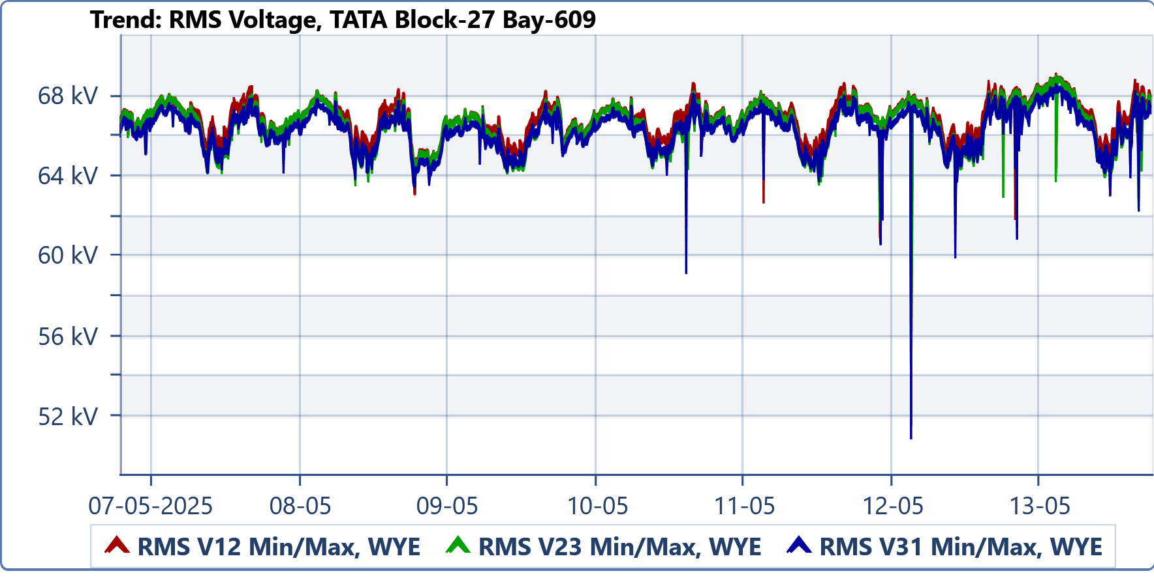

| Parameter | Min | Max | Average |
| --- | --- | --- | --- |
| RMS V12 (Auto) | 51.593 kV | 69.175 kV | 66.922 kV |
| RMS V23 (Auto) | 51.651 kV | 69.09 kV | 66.636 kV |
| RMS V31 (Auto) | 50.902 kV | 68.648 kV | 66.41 kV |

**Trend: RMS Current- M/s. Tata Power Renewable Energy Ltd, Block-27, 50MW Solar Plant. Bay No-609**

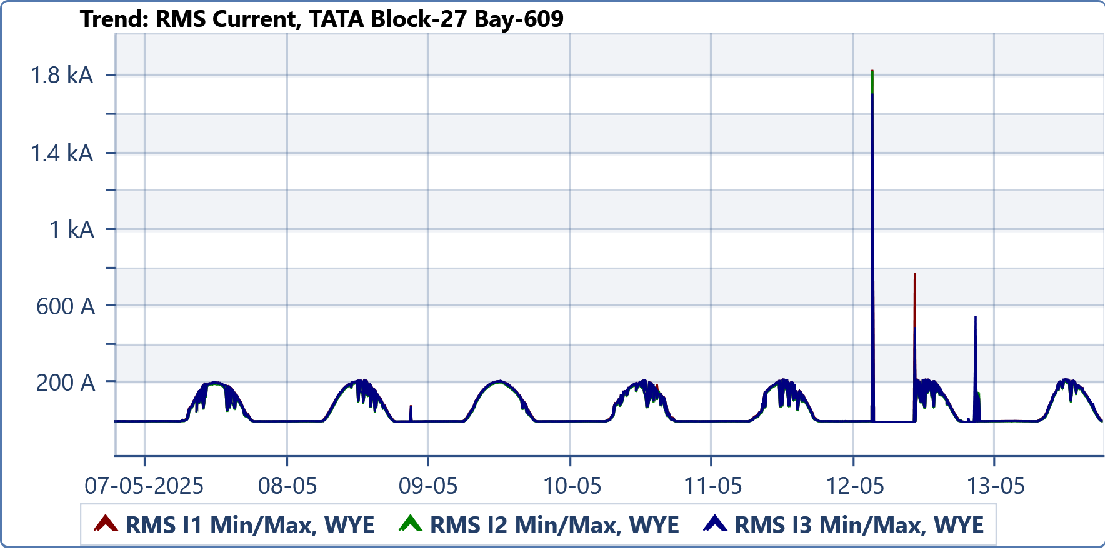

| Parameter | Min | Max | Average |
| --- | --- | --- | --- |
| RMS I1 (Auto) | 0.898 A | 1.834 kA | 60.1 A |
| RMS I2 (Auto) | 1.053 A | 1.829 kA | 57.125 A |
| RMS I3 (Auto) | 0.863 A | 1.71 kA | 59.744 A |

**Trend: Active Power Total (Auto) Average : M/s. Tata Power Renewable Energy Ltd, Block-27, 50MW Solar Plant. Bay No-609**

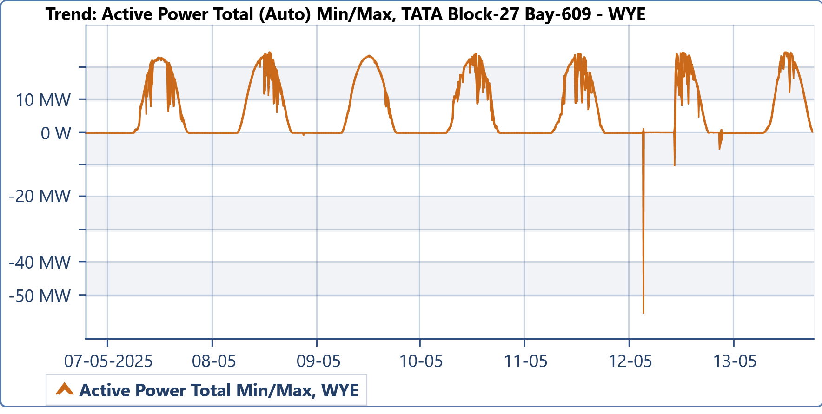

| Parameter | Min | Max | Average |
| --- | --- | --- | --- |
| Active Power Total (Auto) | -55.459 MW | 24.771 MW | 6.429 MW |

**Trend: THD Voltage - M/s. Tata Power Renewable Energy Ltd, Block-27, 50MW Solar Plant. Bay No-609**

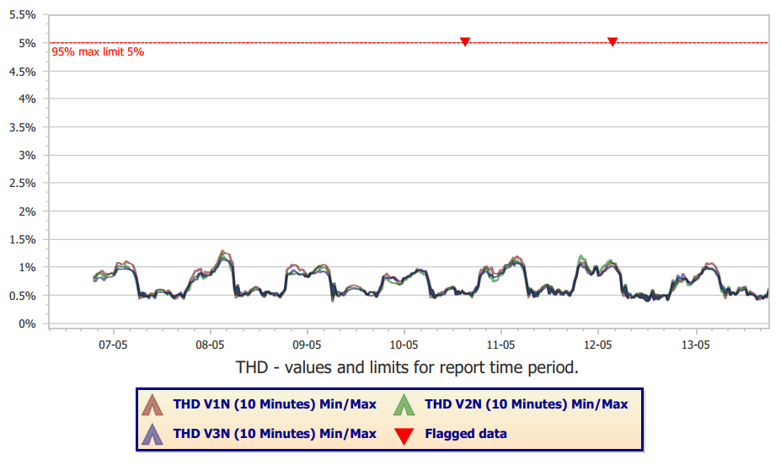

**Trend: Individual Voltage Harmonics - M/s. Tata Power Renewable Energy Ltd, Block-27, 50MW Solar Plant. Bay No-609**

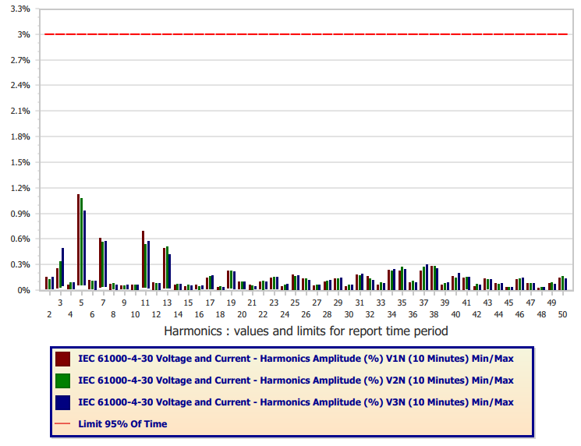

**Trend: TDD Current - M/s. Tata Power Renewable Energy Ltd, Block-27, 50MW Solar Plant. Bay No-609**

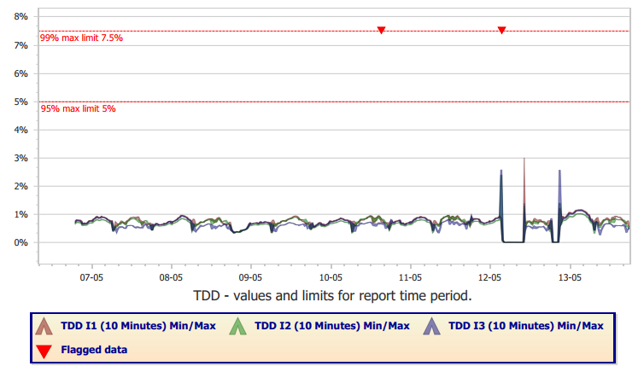

**Trend: Individual Current Harmonics - M/s. Tata Power Renewable Energy Ltd, Block-27, 50MW Solar Plant. Bay No-609**

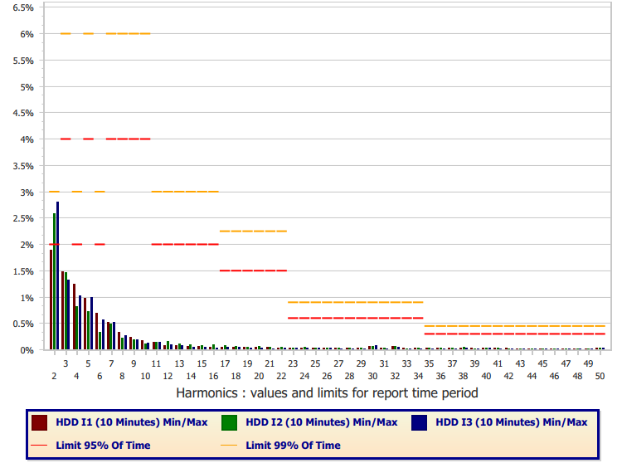

**DC Injection - M/s. Tata Power Renewable Energy Ltd, Block-27, 50MW Solar Plant. Bay No-609**

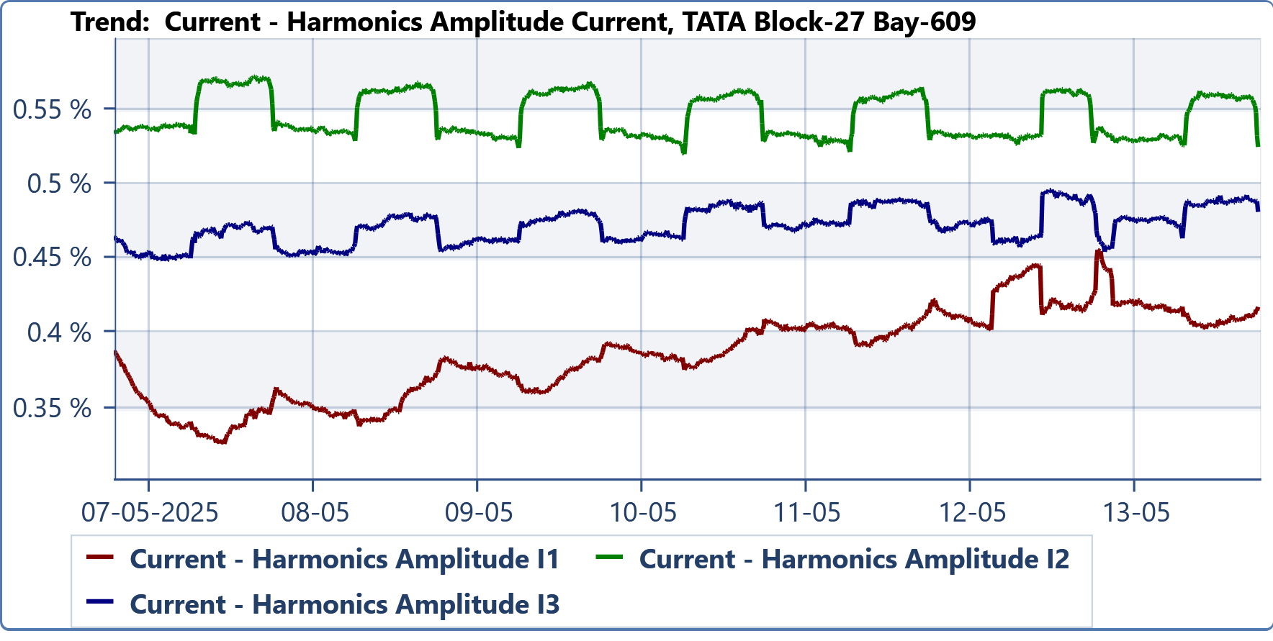

**Trend: Flicker - M/s. Tata Power Renewable Energy Ltd, Block-27, 50MW Solar Plant. Bay No-609**

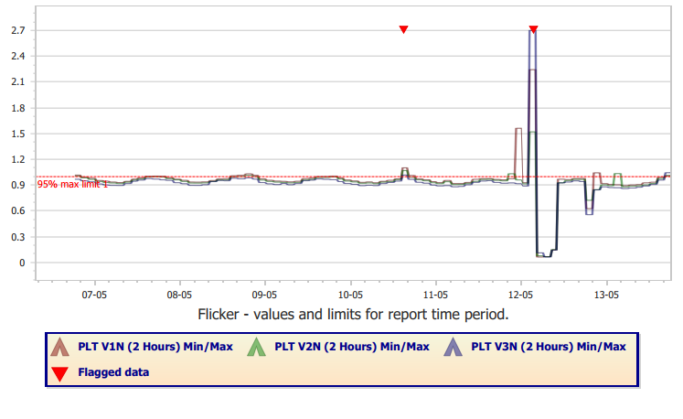

**Summary:**

**RMS Voltage, Current Active Power Apparent Power, Power Factor,**

**M/s. Tata Power Renewable Energy Ltd, Block-27, 50MW Solar Plant. Bay No-609**

**Day 01 Summary**

|  |  |  |  |
| --- | --- | --- | --- |
| Parameter | Min | Max | Average |
| RMS V12 (Half Cycle) | 64.733 kV | 68.549 kV | 67.057 kV |
| RMS V23 (Half Cycle) | 64.118 kV | 68.149 kV | 66.778 kV |
| RMS V31 (Half Cycle) | 64.151 kV | 67.929 kV | 66.542 kV |
| RMS I1 (Half Cycle) | 2.288 A | 208.732 A | 64.75 A |
| RMS I2 (Half Cycle) | 1.88 A | 203.301 A | 61.361 A |
| RMS I3 (Half Cycle) | 2.081 A | 209.447 A | 64.285 A |
| Active Power Total (Cycle) | -140.793 kW | 23.158 MW | 6.957 MW |
| Apparent Power Total (Cycle) | 147.571 kVA | 23.38 MVA | 7.239 MVA |
| Power Factor Total (Cycle) | 0.944 IND | -0.463 IND | 0.961 CAP |

**Day 02 Summary**

|  |  |  |  |
| --- | --- | --- | --- |
| Parameter | Min | Max | Average |
| RMS V12 (Half Cycle) | 64.807 kV | 68.398 kV | 66.879 kV |
| RMS V23 (Half Cycle) | 63.511 kV | 68.314 kV | 66.593 kV |
| RMS V31 (Half Cycle) | 63.825 kV | 67.898 kV | 66.372 kV |
| RMS I1 (Half Cycle) | 2.588 A | 220.822 A | 67.715 A |
| RMS I2 (Half Cycle) | 1.835 A | 213.749 A | 64.305 A |
| RMS I3 (Half Cycle) | 2.372 A | 220.063 A | 67.297 A |
| Active Power Total (Cycle) | -142.802 kW | 24.771 MW | 7.283 MW |
| Apparent Power Total (Cycle) | 164.066 kVA | 25.146 MVA | 7.561 MVA |
| Power Factor Total (Cycle) | 0.943 IND | -0.467 IND | 0.963 CAP |

**Day 03 Summary**

|  |  |  |  |
| --- | --- | --- | --- |
| **Parameter** | **Min** | **Max** | **Average** |
| RMS V12 (Half Cycle) | 63.084 kV | 68.288 kV | 66.257 kV |
| RMS V23 (Half Cycle) | 64.102 kV | 67.88 kV | 65.969 kV |
| RMS V31 (Half Cycle) | 63.441 kV | 67.676 kV | 65.751 kV |
| RMS I1 (Half Cycle) | 1.731 A | 214.656 A | 70.069 A |
| RMS I2 (Half Cycle) | 1.816 A | 209.938 A | 66.863 A |
| RMS I3 (Half Cycle) | 2.028 A | 216.157 A | 69.665 A |
| Active Power Total (Cycle) | -1.014 MW | 23.767 MW | 7.567 MW |
| Apparent Power Total (Cycle) | 120.258 kVA | 23.989 MVA | 7.799 MVA |
| Power Factor Total (Cycle) | 0.928 IND | -0.927 IND | 0.97 CAP |

**Day 04 Summary**

|  |  |  |  |
| --- | --- | --- | --- |
| **Parameter** | **Min** | **Max** | **Average** |
| RMS V12 (Half Cycle) | 62.309 kV | 68.694 kV | 66.802 kV |
| RMS V23 (Half Cycle) | 63.368 kV | 68.246 kV | 66.506 kV |
| RMS V31 (Half Cycle) | 59.146 kV | 68.153 kV | 66.304 kV |
| RMS I1 (Half Cycle) | 2.188 A | 218.472 A | 63.293 A |
| RMS I2 (Half Cycle) | 1.723 A | 214.875 A | 60.242 A |
| RMS I3 (Half Cycle) | 2.092 A | 218.345 A | 62.926 A |
| Active Power Total (Cycle) | -139.159 kW | 24.42 MW | 6.805 MW |
| Apparent Power Total (Cycle) | 137.069 kVA | 24.725 MVA | 7.07 MVA |
| Power Factor Total (Cycle) | 0.918 IND | -0.464 IND | 0.963 CAP |

**Day 05 Summary**

|  |  |  |  |
| --- | --- | --- | --- |
| **Parameter** | **Min** | **Max** | **Average** |
| RMS V12 (Half Cycle) | 62.658 kV | 68.695 kV | 66.964 kV |
| RMS V23 (Half Cycle) | 63.547 kV | 68.366 kV | 66.68 kV |
| RMS V31 (Half Cycle) | 63.715 kV | 68.072 kV | 66.453 kV |
| RMS I1 (Half Cycle) | 1.936 A | 222.488 A | 58.783 A |
| RMS I2 (Half Cycle) | 1.891 A | 216.623 A | 55.535 A |
| RMS I3 (Half Cycle) | 2.177 A | 222.332 A | 58.392 A |
| Active Power Total (Cycle) | -141.415 kW | 24.438 MW | 6.248 MW |
| Apparent Power Total (Cycle) | 126.069 kVA | 24.751 MVA | 6.524 MVA |
| Power Factor Total (Cycle) | 0.95 IND | -0.5 IND | 0.958 CAP |

**Day 06 Summary**

|  |  |  |  |
| --- | --- | --- | --- |
| **Parameter** | **Min** | **Max** | **Average** |
| RMS V12 (Half Cycle) | 51.593 kV | 68.815 kV | 66.959 kV |
| RMS V23 (Half Cycle) | 51.651 kV | 68.386 kV | 66.665 kV |
| RMS V31 (Half Cycle) | 50.902 kV | 68.164 kV | 66.427 kV |
| RMS I1 (Half Cycle) | 0.898 A | 1.834 kA | 44.007 A |
| RMS I2 (Half Cycle) | 1.154 A | 1.829 kA | 42.089 A |
| RMS I3 (Half Cycle) | 1.027 A | 1.71 kA | 43.894 A |
| Active Power Total (Cycle) | -55.459 MW | 24.727 MW | 4.656 MW |
| Apparent Power Total (Cycle) | 4.863 kVA | 152.889 MVA | 4.864 MVA |
| Power Factor Total (Cycle) | -0.765 CAP | -0.947 IND | 0.957 CAP |

**Day 07 Summary**

|  |  |  |  |
| --- | --- | --- | --- |
| **Parameter** | **Min** | **Max** | **Average** |
| RMS V12 (Half Cycle) | 61.467 kV | 69.175 kV | 67.562 kV |
| RMS V23 (Half Cycle) | 62.247 kV | 69.09 kV | 67.267 kV |
| RMS V31 (Half Cycle) | 60.847 kV | 68.648 kV | 67.043 kV |
| RMS I1 (Half Cycle) | 0.969 A | 223.985 A | 59.343 A |
| RMS I2 (Half Cycle) | 1.053 A | 270.386 A | 56.435 A |
| RMS I3 (Half Cycle) | 0.863 A | 552.7 A | 58.948 A |
| Active Power Total (Cycle) | -5.177 MW | 24.771 MW | 6.317 MW |
| Apparent Power Total (Cycle) | 11.329 kVA | 25.006 MVA | 6.611 MVA |
| Power Factor Total (Cycle) | -0.947 CAP | -0.923 IND | 0.956 CAP |

**All 7 Days Summary**

|  |  |  |  |
| --- | --- | --- | --- |
| **Parameter** | **Min** | **Max** | **Average** |
| RMS V12 (Half Cycle) | 51.593 kV | 69.175 kV | 66.922 kV |
| RMS V23 (Half Cycle) | 51.651 kV | 69.09 kV | 66.636 kV |
| RMS V31 (Half Cycle) | 50.902 kV | 68.648 kV | 66.41 kV |
| RMS I1 (Half Cycle) | 0.898 A | 1.834 kA | 60.1 A |
| RMS I2 (Half Cycle) | 1.053 A | 1.829 kA | 57.124 A |
| RMS I3 (Half Cycle) | 0.863 A | 1.71 kA | 59.744 A |
| Active Power Total (Cycle) | -55.459 MW | 24.771 MW | 6.429 MW |
| Apparent Power Total (Cycle) | 4.863 kVA | 152.889 MVA | 6.692 MVA |
| Power Factor Total (Cycle) | -0.947 CAP | -0.947 IND | 0.961 CAP |

Note:

1. The testing & the report has been carried out based on the detailed Guidelines for Measurement of Harmonics, Direct Current (DC) Injection & Flicker as per SRLDC / POSOC Guidelines, Revision-R1 dated September 24, 2021. However limits have been taken as per latest IEEE -519 : 2022.
2. This report is only for the measurement and particular analysis carried out by IPR Technologies Pvt Ltd., Bangalore for the above project site.
3. This document is intended for the sole use of the Customer, this report cannot be reproduced in part under any circumstances and this document must be read in its entirety and is subject to any assumptions and qualifications expressed therein as well as in any other relevant communications in connection with it. This document may contain detailed technical data which is intended for use only by persons possessing requisite expertise in its subject matter. This report shall not be used for any other purpose other than the intended purpose.
4. Only the tests asked for by the customer / POSOCO have been carried out as per the procedure released by them.
5. This test report prepared based on the test / measured data during the testing period is given as per instrument status while testing.



|  |  |
| --- | --- |
| (IPR power Quality Team)  Measurement carried & checked | (V.Kiran)  Approved |

